Chapter 5
Storing and Retrieving Data with ADO.NET
About This Chapter
In this chapter, you’ll learn how to use Microsoft ADO.N Lesson 1: Accessing Data with ADO.NET
Visual Studio .NET provides access to databases through the set of tools and namespaces collectively referred to as Microsoft ADO.NET. Data access in ADO.NET is standardized to be mostly independent of the source of the data—once you’ve established a connection to a database, you use a consistent set of objects, properties, and methods, regardless of the type of database you are using.
In this lesson, you’ll learn how to use ADO.NET to connect to a database and how to read, modify, and delete records from that database. The lessons in this chapter use the Contacts database (Contacts.mdf) included on the companion CD for all the examples. Be sure to install that database before trying to work with the examples.
After this lesson, you will be able to
- Understand the structure and steps involved in accessing data through ADO.NET
- Connect to a database and create a data set at design time
- Explain how ADO.NET refers to data items using type information
- Add, delete, and modify records in a data set
- Update a database from a data set
- Connect to a database and create a data set at run time
Estimated lesson time: 35 minutes
Understanding ADO.NET
There are four layers to data access in ADO.NET:
- The physical data store
This can be a SQL, an OLE, or an Oracle database or an Extensible Markup Language (XML) file.
- The data provider
This consists of the Connection object and command objects that create the in-memory representation of the data.
- The data set
This is the in-memory representation of the tables and relationships that you work with in your application.
- The data view
This determines the presentation of a table in the data set. You typically use data views to filter or sort data to present to the user. Each data set has a default data view matching the row order used to create the data set.
The data provider layer provides abstraction between the physical data store and the data set you work with in code. After you’ve created the data set, it doesn’t matter where the data set comes from or where it is stored. This architecture is referred to as disconnected because the data set is independent of the data store.
Figure 5-1 shows the ADO.NET object model in action.
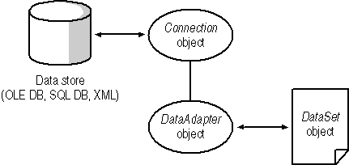
Figure 5-1. The Connection and DataAdapter objects
There are currently three types of database connection in ADO.NET:
- Use an OleDbConnection object to connect to a Microsoft Access or third-party database, such as MySQL.
OLE database connections use the OleDbDataAdapter object to perform commands and return data.
- Use a SqlConnection object to connect to a Microsoft SQL Server database.
SQL database connections use the SqlDbDataAdapter object to perform commands and return data.
- Use an OracleConnection object to connect to Oracle databases.
Oracle database connections use the OracleDataAdapter object to perform commands and return data. This connection object was introduced in Microsoft .NET Framework version 1.1.
In addition to these database connections, you can access XML files directly from data sets using the DataSet object’s ReadXML and WriteXML methods. XML files are static representations of data sets. ADO.NET uses XML for all data transfer across the Internet.
ADO.NET provides its objects, properties, and methods through the three namespaces described in Table 5-1. The System.Data.SqlClient, System.Data.OracleClient, and System.Data.OleDb namespaces listed in the table provide equivalent features for Microsoft SQL Server and other databases, respectively.
Table 5-1. ADO.NET Namespaces
Namespace | Provides
System.Data | Classes, types, and services for creating and accessing data sets and their subordinate objects
System.Data.SqlClient | Classes and types for accessing Microsoft SQL Server databases
System.Data.OracleClient | Classes and types for accessing Oracle databases (Microsoft .NET Framework version 1.1 and later)
System.Data.OleDb | Classes and types for accessing other databases
When working with databases in code, you need to add the following Imports or using declarations at the top of your code module:
Visual Basic .NET
Imports System.Data
' For Microsoft SQL Server database connections.
Imports System.Data.SqlClient
' For Oracle database connections.
Imports System.Data.OracleClient
' For other database connections.
Imports System.Data.OleDb
Visual C#
using System.Data;
// For Microsoft SQL Server database connections.
using System.Data.SqlClient;
// For Oracle database connections.
using System.Data.OracleClient;
// For other database connections.
using System.Data.OleDb;
To access a database through ADO.NET, follow these steps:
- Create a connection to the database using a connection object.
- Invoke a command to create a DataSet object using an adapter object.
- Use the DataSet object in code to display data or to change items in the database.
- Invoke a command to update the database from the DataSet object using an adapter object.
- Close the database connection if you explicitly opened it in step 2 using the Open method. Invoking commands without first invoking the Open method implicitly opens and closes the connection with each request.
The following sections discuss each of these steps in more detail.
Connecting to a Database
Use the Server Explorer to connect to a database in Visual Studio.
To connect to a database in the Visual Studio design environment, follow these steps:
- From the View menu, choose Server Explorer. Visual Studio displays the Server Explorer window.
- In the Server Explorer, click Connect To Database on the toolbar. Visual Studio .NET displays the DataLink Properties dialog box shown in Figure 5-2.
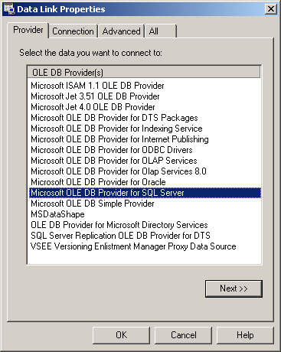
Figure 5-2. The DataLink Properties dialog box
- Click the Provider tab to select the type of database for the connection. By default, the database provider is Microsoft OLE DB Provider For SQL Server. That is the correct selection if your database is running under Microsoft SQL Server. To access a different type of database, select the appropriate provider. For instance, to access a Microsoft Access database directly, select Microsoft Jet 4.0 OLE DB Provider.
- Click the Connection tab to specify the database to connect to. Changing the database provider in step 3 changes the connection settings, as shown in Figure 5-3.
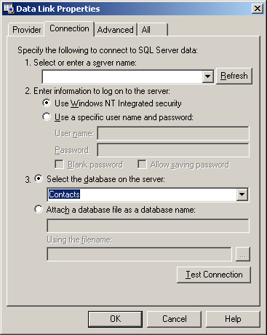
Figure 5-3. The Connection tab
- Enter the connection settings and click Test Connection to make sure your settings are correct. Click OK when the connection succeeds. Visual Studio adds the data connection to the Server Explorer, as shown in Figure 5-4.
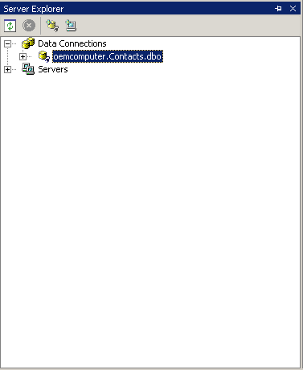
Figure 5-4. The Server Explorer
- Clicking the plus signs in the Server Explorer expands items. To view the tables in a data connection, expand the items under the data connection, and then expand the items under Tables. Visual Studio displays the tables, as shown in Figure 5-5.
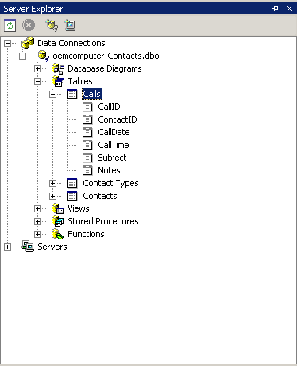
Figure 5-5. Expanded items in the Server Explorer
- To add a data item to your application, drag the item from the Server Explorer onto your Web form. For instance, create a new Web Forms project, and drag the Contacts table shown in Figure 5-5 onto the Web form. When you drop the table onto the Web form, Visual Studio creates connection and adapter objects with the appropriate settings, as shown in Figure 5-6.
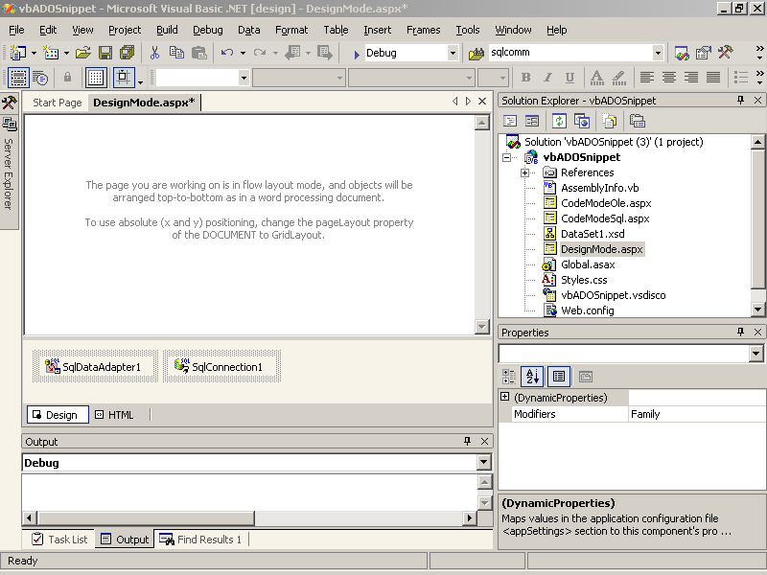
Figure 5-6. Connection and adapter objects
IMPORTANT
Web applications run using the ASPNET user account. The SQL database administrator will have to set up this account and grant it permissions before your Web application will have access to a SQL database. For file-based databases, such as Microsoft Access, you must grant permissions on the database file to the ASPNET user account using Windows file security settings.
Creating a Data Set
Use the data connection and adapter objects created in step 7 in the preceding section to create a data set.
To create a data set in Design mode, follow these steps:
- Right-click the data adapter object, and select Generate Dataset from the shortcut menu. Visual Studio displays the Generate Dataset dialog box, as shown in Figure 5-7.
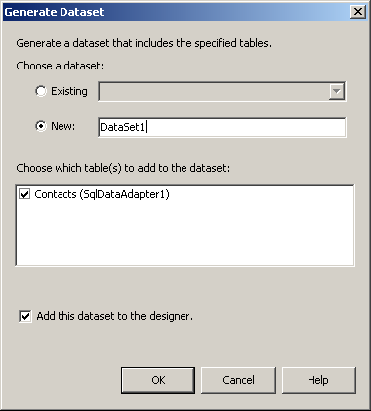
Figure 5-7. The Generate Dataset dialog box
- Select the Contacts table to add to the data set, and click OK. Visual Studio creates a new DataSet object and adds it to the Web form.
To view the data in the data set in Design mode, right-click the DataSet object, and then select View Schema from the shortcut menu. Visual Studio displays the data set in the XML Designer window, as shown in Figure 5-8.
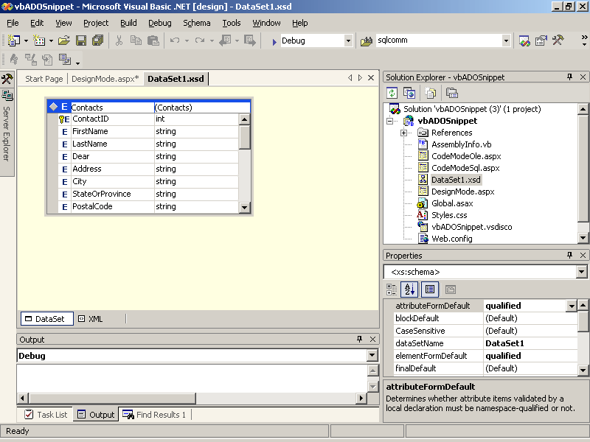
Figure 5-8. Data set schema in Design mode
Displaying a Data Set
To display the data set on the Web form at run time, follow these steps:
- Add a control to the Web form to display the data. For instance, add a DataGrid control to the Web form.
- Set the data set as the data source for the control. For instance, for the DataGrid control, click the Property Builder link in the Properties window, set the DataSource property to the DataSet object, and set the DataMember property to a table in the data set, as shown in Figure 5-9.
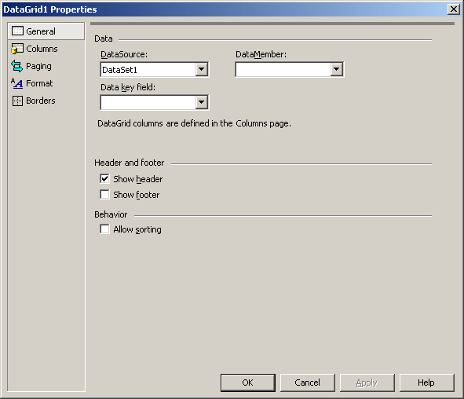
Figure 5-9. Data binding on a DataGrid control
- Set the columns to display in the control. For the DataGrid control, click the Columns item in the Properties dialog box, clear the Create Columns Automatically At Run Time check box, and then add the columns to display from the Available Columns list, as shown in Figure 5-10. Click OK when you have finished.
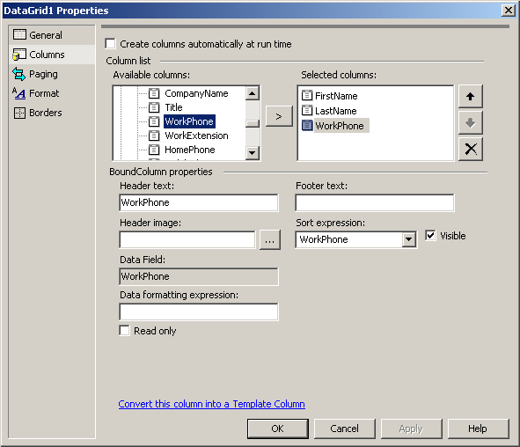
Figure 5-10. Adding columns to display in the DataGrid control
- Add code to the Web form’s Page_Load event procedure to fill the data set from the data adapter and to bind the data from the DataSet object to the control. For example, the following code displays the data in the DataGrid control created in the preceding steps:
Visual Basic .NET
Private Sub Page_Load(ByVal sender As System.Object, _
ByVal e As System.EventArgs) Handles MyBase.Load
' Fill the data set.
SqlDataAdapter1.Fill(DataSet1)
' Update the DataGrid.
DataGrid1.DataBind()
End Sub
Visual C#
private void Page_Load(object sender, System.EventArgs e)
{
// Fill the data set.
sqlDataAdapter1.Fill(DataSet1);
// Update the DataGrid.
dataGrid1.DataBind();
}
- Run the application. When the page loads, the data set is displayed, as shown in Figure 5-11.
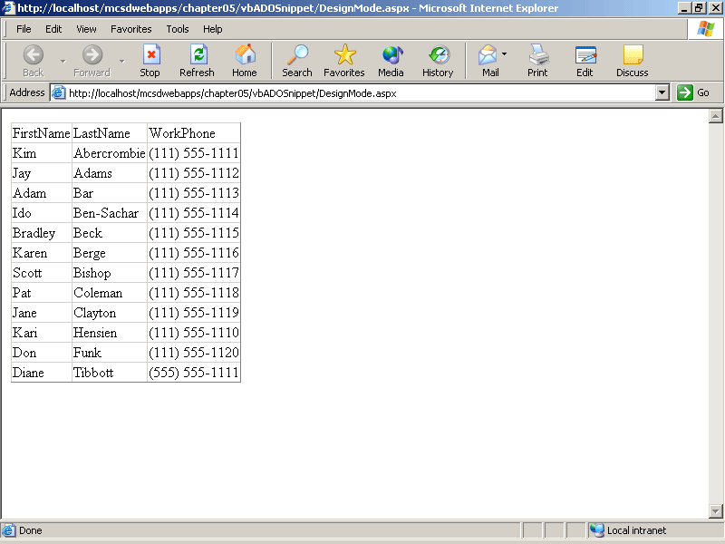
Figure 5-11. The DataGrid control at run time
TIP
Because you are filling the data set and binding the data to the DataGrid control in the Page_Load event procedure, you don’t need to maintain state information for the DataGrid control. Turning off state information improves performance because the data in the DataGrid control does not have to be saved to the page’s ViewState between requests. Set the DataGrid control’s EnableViewState property to False to turn off state maintenance for the control.
Creating a Custom Data View
The preceding section displays the default view of the data set in a DataGrid control, which is the quickest way to display data. However, you’ll often want to sort and filter data within the DataGrid control. To do that, you’ll need to bind the DataGrid to the DataSet object’s DataView property.
To create and display a data view in Design mode:
- Drag a DataView control from the Data Controls tab of the Toolbox to the Web form’s Design window.
- Set the Table property of the DataView control to one of the tables in a DataSet object.
- Add a DataGrid control to the form and set its DataSource property to the DataView control created in step 1.
After you’ve created a data view in Design mode, you can use the data view to change the sort order or apply filters to data displayed in a DataGrid control. For example, the following procedures change the sort order and apply a filter to a data view displayed in a DataGrid control:.
Visual Basic .NET
Private Sub Page_Load(ByVal sender As System.Object, _
ByVal e As System.EventArgs) Handles MyBase.Load
' Fill data set.
SqlDataAdapter1.Fill(DataSet11)
' Bind to data grid.
DataGrid1.DataBind()
End Sub

Private Sub DataGrid1_SortCommand(ByVal source As Object, _
ByVal e As System.Web.UI.WebControls.DataGridSortCommandEventArgs) _
Handles DataGrid1.SortCommand
' Change the sorting in the data view.
DataView1.Sort = e.SortExpression
' Bind to display the new view.
DataGrid1.DataBind()
End Sub

Private Sub butFilter_Click(ByVal sender As System.Object, _
ByVal e As System.EventArgs) Handles butFilter.Click
' Apply a filter.
DataView1.RowFilter = "FirstName = 'New'"
End Sub
Visual C#
// From Web Form Designer generated region.
private void InitializeComponent()
{
// generated statements omitted here...
this.Load += new System.EventHandler(this.Page_Load);
this.butFilter.Click += new
System.EventHandler(this.butFilter_Click);
this.dataGrid1.SortCommand += new
DataGridSortCommandEventHandler(dataGrid1_SortCommand);
}

private void Page_Load(object sender, System.EventArgs e)
{
// Fill data set.
SqlDataAdapter1.Fill(DataSet11);
// Bind to data grid.
DataGrid1.DataBind();
}

private void dataGrid1_SortCommand(object source,
DataGridSortCommandEventArgs e)
{
// Change the sorting in the data view.
dataView1.Sort = e.SortExpression;
}

private void butFilter_Click(object sender, System.EventArgs e)
{
// Apply a filter.
dataView1.RowFilter = "FirstName = 'New'";
}
Changing Records in a Database
The DataSet object is the central object in ADO.NET. Any additions, deletions, or changes to records in a database are generally done through a DataSet object.
To change records through a DataSet object, follow these steps:
- Get a DataSet object as described in the preceding sections.
- Modify the DataSet object.
- Update the database from the DataSet object by calling the data adapter’s Update method.
You use the Tables, Rows, and Columns collections to get to data items in a DataSet object, as shown in Figure 5-12.
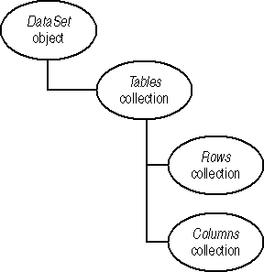
Figure 5-12. DataSet collections
How ADO.NET Refers to Objects
When you create connection, adapter, and data set objects in Design mode, you enable data typing for those objects. This means that you can use the specific names from the database schema to identify tables, rows, and fields. This is a big change from Microsoft ActiveX Data Objects (ADO), which provided only untyped references to data objects.
The following equivalent lines of code show a typed reference vs. an untyped reference to an object from a database:
Visual Basic .NET
' Typed reference to the Contacts table's HomePhone column.
DataSet1.Contacts.HomePhoneColumn.Caption = "@Home"
' Untyped reference to the Contacts table's HomePhone column.
DataSet1.Tables("Contacts").Columns("HomePhone").Caption = "@Home"
Visual C#
// Typed reference to the Contacts table's HomePhone column.
dataSet1.Contacts.HomePhoneColumn.Caption = "@Home";
// Untyped reference to the Contacts table's HomePhone column.
dataSet1.Tables["Contacts"].Columns["HomePhone"].Caption = "@Home";
The first line in the preceding code is not only easier to type and to read, but also much less error prone, because Visual Studio checks data types as you work, flagging any typos as unrecognized references.
In general, you should use typed references when working with data objects. The exception to this rule occurs when you don’t know the specific object you are working with. Usually, this situation arises when the data source is supplied at run time rather than at design time.
Type information for data objects comes from the XML Schema that Visual Studio generates when you create a data set in Design mode.
To view type information for a data set, right-click the data set in the Design window and select View Schema from the shortcut menu. Visual Studio displays the data set in the XML Designer, as shown in Figure 5-13.
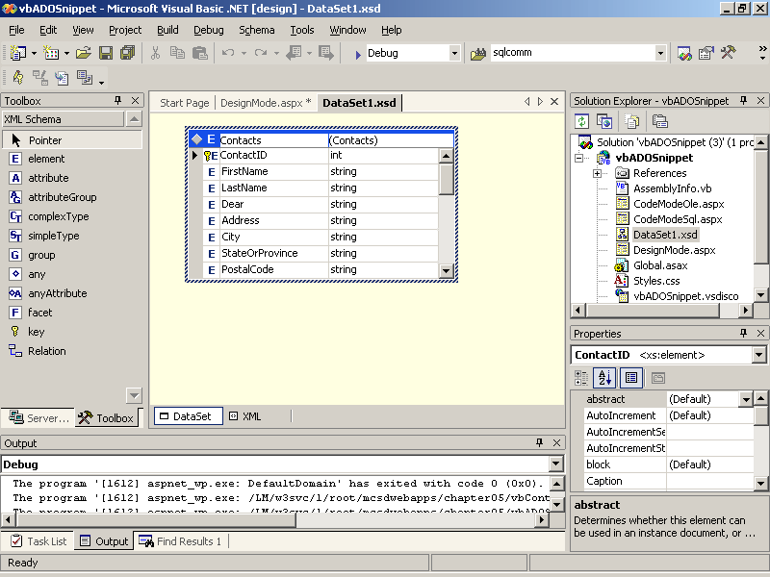
Figure 5-13. Viewing type information
You can use the XML Designer to add elements, specify unique keys, and view or change the data types of elements in a data set.
Adding, Changing, and Deleting Rows
Use the Rows collection to add, change, or delete rows in the DataSet object’s Table object. To add a record to a data set, create a new Row object and add it to the DataSet object’s Rows collection, as shown in the following code:
Visual Basic .NET
' Uses connection, adapter, and data set created in Design mode.
Private Sub butAddRow_Click(ByVal sender As System.Object, _
ByVal e As System.EventArgs) Handles butAddRow.Click
' Create a new row object for the Contacts table.
Dim rowNew As DataSet1.ContactsRow = DataSet1.Contacts.NewRow
' Add data to the columns in the row.
rowNew.ContactID = m_NextID
rowNew.FirstName = "New"
rowNew.LastName = "User " + m_NextID.ToString()
rowNew.WorkPhone = "(111) 555-1212"
' Add the row to the data set.
DataSet1.Contacts.Rows.Add(rowNew)
End Sub
Visual C#
// Uses connection, adapter, and data set created in Design mode.
private void butAdd_Click(object sender, System.EventArgs e)
{
// Create a new row object for the Contacts table.
DataSet1.ContactsRow rowNew =
dataSet1.Contacts.NewContactsRow();
// Add data to the columns in the row.
rowNew.ContactID = m_NextID;
rowNew.FirstName = "New";
rowNew.LastName = "User " + m_NextID.ToString();
rowNew.WorkPhone = "(111) 555-1212";
// Add the row to the data set.
dataSet1.Contacts.AddContactsRow(rowNew);
}
To change a row in a data set, get a Row object from the table using the FindBy method, and then make changes to the fields in the row, as shown in the following code:
Visual Basic .NET
' Uses connection, adapter, and data set created in Design mode.
Private Sub butChangeRow_Click(ByVal sender As System.Object, _
ByVal e As System.EventArgs) Handles butChangeRow.Click
' Declare a row object.
Dim rowChange As DataSet1.ContactsRow
' Get the last row using the primary key.
rowChange = DataSet1.Contacts.FindByContactID(m_NextID - 1)
' Change a field in the row.
rowChange.WorkPhone = "(111) 555-9000"
End Sub
Visual C#
// Uses connection, adapter, and data set created in Design mode.
private void butChange_Click(object sender, System.EventArgs e)
{
// Declare a row object.
DataSet1.ContactsRow rowChange;
// Get the row to change using the primary key.
rowChange = dataSet1.Contacts.FindByContactID(m_NextID - 1);
// Change a field in the row.
rowChange.WorkPhone = "(555) 222-9000";
}
To delete a row in a data set, get a Row object from the table using the FindBy method, and then delete the row using the Row object’s Delete method, as shown here:
Visual Basic .NET
' Uses connection, adapter, and data set created in Design mode.
Private Sub butDeleteRow_Click(ByVal sender As System.Object, _
ByVal e As System.EventArgs) Handles butDeleteRow.Click
' Declare a row object.
Dim rowDelete As DataSet1.ContactsRow
' Get the last row
rowDelete = DataSet1.Contacts.FindByContactID(m_NextID - 1)
' Delete the row.
rowDelete.Delete()
End Sub
Visual C#
// Uses connection, adapter, and data set created in Design mode.
private void butDelete_Click(object sender, System.EventArgs e)
{
// Declare a row object.
MCSDWebAppsCS.Chapter05.DataSet1.ContactsRow rowDelete;
// Get the row to delete
rowDelete = dataSet1.Contacts.FindByContactID(m_NextID - 1);
// Delete the row.
rowDelete.Delete();
}
Updating the Database from the DataSet
Use the data adapter’s Update method to update the database with changes from a DataSet object. You will usually want to do this after all of the control events on a page have been processed; therefore, the Update method is usually called from the Page_PreRender event procedure, as shown here:
Visual Basic .NET
' Uses connection, adapter, and data set created in Design mode.
Private Sub Page_PreRender(ByVal sender As Object, _
ByVal e As System.EventArgs) Handles MyBase.PreRender
' Update the database with changes from the data set.
SqlDataAdapter1.Update(DataSet1)
' Rebind to reflect the data set changes in the DataGrid
DataGrid1.Bind()
End Sub
Visual C#
// From Web Designer generated code region.
private void InitializeComponent()
{
// generated code omitted...
this.PreRender += new EventHandler(Page_PreRender);
}

// Uses connection, adapter, and data set created in Design mode.
private void Page_PreRender(object sender, EventArgs e)
{
// Update the database with changes from the data set.
sqlDataAdapter1.Update(dataSet1);
// Refresh data grid just before the page is displayed.
DataGrid1.DataBind();
}
When you update a database from a data set, ADO.NET follows these steps:
- Determines the changes to the data set by checking each DataRow object’s RowState property. Possible values are Added, Deleted, Modified, Unchanged, or Detached.
- Invokes the adapter object’s InsertCommand, DeleteCommand, or UpdateCommand properties to make the required changes in the database. These operations automatically open the database connection and close it when finished.
- Resets the updated DataRow objects’ RowState properties to Unchanged.
The adapter object’s InsertCommand, DeleteCommand, and UpdateCommand properties are generated automatically from the adapter object’s SelectCommand when you create a data set from a data adapter in Design mode. Each of these properties represents an OleCommand or SqlCommand object. Command objects have the following properties that determine how the command is executed:
- The CommandText property contains the SQL statement or the stored procedure name to perform the command.
- The CommandType property determines how the command is performed by the following possible settings:
  - The StoredProcedure setting executes the command as a procedure stored in the database.
  - The Text setting executes the command as a SQL statement. (This is the default.)
  - The TableDirect setting returns the entire table. This setting applies only to OLE DB .NET data providers.
You can change the contents of the data set and how the data set is updated by changing the SQL statements used by these command objects.
To view or modify these commands, follow these steps:
- In the Properties window, double-click the command property you want to change. This expands the list of properties that apply to the command object, as shown in Figure 5-14.
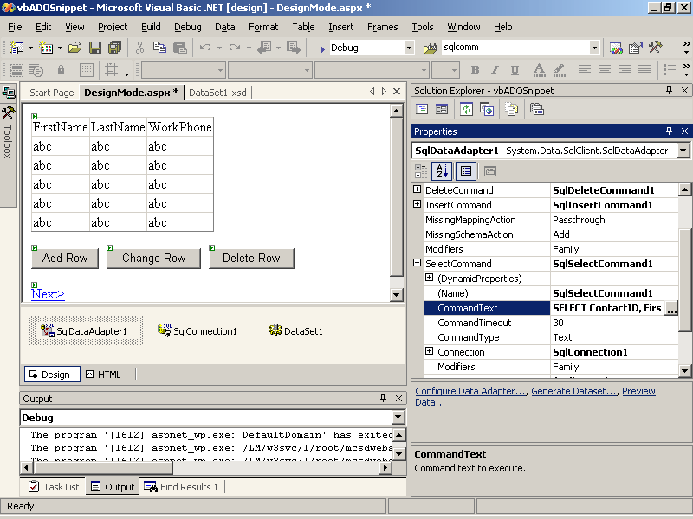
Figure 5-14. Viewing and modifying SQL commands
- Select the CommandText property for the command, and then click the ellipsis button to the right of the property setting. Visual Studio displays the Query Builder dialog box, as shown in Figure 5-15.
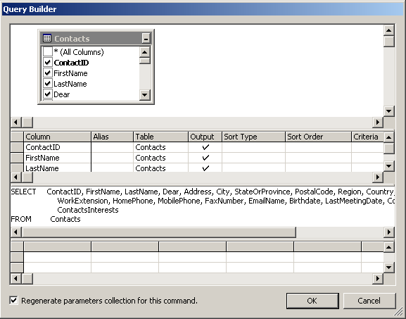
Figure 5-15. The Query Builder dialog box
- Select the columns to include in the command by selecting the check boxes next to the data field names in the table pane of the Query Builder dialog box, or type the SQL statement directly in the command pane of the Query Builder. When you have finished, click OK to close the dialog box.
Creating a Database Connection at Run Time
Creating data objects in Design mode is a great way to learn about data access in ADO.NET because Visual Studio generates the connection and adapter object property settings for you. Some of the property settings, such as ConnectionString, can be difficult and confusing to construct without the help of Design mode. After you’ve created a connection in Design mode, you can cut and paste the property settings to create similar connections in code.
Using data-access objects in code follows the same sequence of events as it does in Design mode:
- Create the data connection object.
- Create a data adapter object.
- Create a data set object.
- Invoke methods on the adapter object to fill or update the data set.
- Use data binding or another technique to display the data from the data set.
For example, the following code creates data objects and displays data from a Microsoft SQL data provider:
Visual Basic .NET
Dim m_adptContactMgmt As SqlDataAdapter

Private Sub Page_Load(ByVal sender As System.Object, _
ByVal e As System.EventArgs) Handles MyBase.Load
' (1) Create the data connection.
Dim ContactMgmt As New SqlConnection _
("server=(local);database=Contacts;Trusted_Connection=yes")
' (2) Create a data adapter.
m_adptContactMgmt = New _
SqlDataAdapter("select * from Contacts", ContactMgmt)
' (3) Create a data set.
Dim dsContacts As New DataSet
' (4) Fill the data set.
m_adptContactMgmt.Fill(dsContacts, "Contacts")
' (5) Display the table in a data grid using data binding.
DataGrid1.DataSource = dsContacts.Tables("Contacts").DefaultView
DataGrid1.DataBind()
End Sub
Visual C#
SqlDataAdapter m_adptContactMgmt;

private void Page_Load(object sender, System.EventArgs e)
{
// (1) Create the data connection.
SqlConnection ContactMgmt = new SqlConnection("server=(local);" +
"database=Contacts;Trusted_Connection=yes");
// (2) Create a data adapter.
m_adptContactMgmt = new SqlDataAdapter("select * from Contacts",
ContactMgmt);
// (3) Create a data set.
DataSet dsContacts = new DataSet();
// (4) Fill the data set.
m_adptContactMgmt.Fill(dsContacts, "Contacts");
// (5) Display the table in a data grid using data binding.
DataGrid1.DataSource = dsContacts.Tables["Contacts"].DefaultView;
DataGrid1.DataBind();
}
Updating a Run-Time Database Connection
As mentioned earlier in this section, ADO.NET uses the adapter object’s InsertCommand, DeleteCommand, and UpdateCommand properties to update the database from the data set. When you create a data adapter at run time, you need to generate these properties before you can call the adapter object’s Update method.
To generate InsertCommand, DeleteCommand, and UpdateCommand properties at run time, follow these steps:
- Set the adapter object’s SelectCommand. The SelectCommand is set by the data adapter’s constructor, or it can be set using the SelectCommand property. ADO.NET uses the SelectCommand’s CommandText property to generate the settings for the InsertCommand, DeleteCommand, and UpdateCommand properties.
- Create a command builder object for the adapter object. The command builder object is dependent on the data provider, so it has three forms: SqlCommandBuilder, OracleCommandBuilder, and OleDbCommandBuilder.
The following code creates a database connection, data adapter, and data set in code and then displays that data set in a DataGrid (1 through 5). Next the code adds a row to the data set (6), creates a command builder for the adapter object (7), and then uses the dynamically created commands to update the database in the Page_PreRender event procedure (8):
Visual Basic .NET
Dim m_NextID As Integer
Dim m_dtContacts As DataTable
Dim m_adptContactMgmt As SqlDataAdapter

Private Sub Page_Load(ByVal sender As System.Object, _
ByVal e As System.EventArgs) Handles MyBase.Load
' (1) Create the data connection.
Dim ContactMgmt As New SqlConnection _
("server=(local);database=Contacts;Trusted_Connection=yes")
' (2) Create a data adapter.
m_adptContactMgmt = New _
SqlDataAdapter("select * from Contacts", ContactMgmt)
' (3) Create a data set.
Dim dsContacts As New DataSet
' (4) Fill the data set.
m_adptContactMgmt.Fill(dsContacts, "Contacts")
' Get the data table
m_dtContacts = dsContacts.Tables("Contacts")
' Create a primary key on data table.
m_dtContacts.PrimaryKey = New _
DataColumn() {m_dtContacts.Columns("ContactID")}
' Get a new, unique row ID.
m_NextID = GetNewID(m_dtContacts)
' (5) Display the table in a data grid using data binding.
DataGrid1.DataSource = m_dtContacts.DefaultView
End Sub

Private Sub butAdd_Click(ByVal sender As System.Object, _
ByVal e As System.EventArgs) Handles butAdd.Click
' (6) Create and add a new row.
' Create a new row object.
Dim rowInsert As DataRow = m_dtContacts.NewRow
' Add data to fields in the row.
rowInsert("ContactID") = m_NextID
rowInsert("FirstName") = "New"
rowInsert("LastName") = "User " + m_NextID.ToString()
rowInsert("WorkPhone") = "(555) 555-1212"
' Add the row to the data set.
m_dtContacts.Rows.Add(rowInsert)
End Sub

Private Sub Page_PreRender(ByVal sender As Object, _
ByVal e As System.EventArgs) Handles MyBase.PreRender
' (7) Create insert, delete, and update commands automatically.
Dim cmdContactMgmt As SqlCommandBuilder = New _
SqlCommandBuilder(m_adptContactMgmt)
' (8) Update the database.
m_adptContactMgmt.Update(m_dtContacts)
' Bind data to DataGrid to update the display.
DataGrid1.DataBind()
End Sub

' Helper function to get a new, valid row ID.
Function GetNewID(ByVal dt As DataTable) As Integer
' Get a new row number.
Dim NextID As Integer = dt.Rows.Count + 1
' If it isn't found in the table, return it.
If IsNothing(dt.Rows.Find(NextID)) Then Return NextID
' Otherwis, check for free IDs between 1 and the row count.
For NextID = 1 To dt.Rows.Count
' Check if this ID already exists.
If IsNothing(dt.Rows.Find(NextID)) Then
Return NextID
End If
Next
' Failed, return zero.
Return 0
End Function
Visual C#
int m_NextID;
DataTable m_dtContacts;
SqlDataAdapter m_adptContactMgmt;

private void Page_Load(object sender, System.EventArgs e)
{
// (1) Create the data connection.
SqlConnection ContactMgmt = new SqlConnection("server=(local);" +
"database=Contacts;Trusted_Connection=yes");
// (2) Create a data adapter.
m_adptContactMgmt = new SqlDataAdapter("select * from Contacts",
ContactMgmt);
// (3) Create a data set.
DataSet dsContacts = new DataSet();
// (4) Fill the data set.
m_adptContactMgmt.Fill(dsContacts, "Contacts");
// Get the data table
m_dtContacts = dsContacts.Tables["Contacts"];
// Create a primary key on data table.
m_dtContacts.PrimaryKey = new DataColumn[]
{m_dtContacts.Columns["ContactID"]};
// Get a new, unique row ID.
m_NextID = GetNewID(m_dtContacts);
// (5) Display the table in a data grid using data binding.
DataGrid1.DataSource = m_dtContacts.DefaultView;
}

private void butAdd_Click(object sender, System.EventArgs e)
{
// (6) Create a new row object for the Contacts table.
DataRow rowNew = m_dtContacts.NewRow();
// Add data to the columns in the row.
rowNew["ContactID"] = m_NextID;
rowNew["FirstName"] = "New";
rowNew["LastName"] = "User " + m_NextID.ToString();
rowNew["WorkPhone"] = "(111) 555-1212";
// Add the row to the data set.
m_dtContacts.Rows.Add(rowNew);
}

private void Page_PreRender(object sender, EventArgs e)
{
// (7) Create insert, delete, and update commands automatically.
SqlCommandBuilder cmdContactMgmt = new
SqlCommandBuilder(m_adptContactMgmt);
// (8) Update the database.
m_adptContactMgmt.Update(m_dtContacts);
// Bind data to DataGrid to update the display.
DataGrid1.DataBind();
}

// Helper function to get a new, valid row ID.
int GetNewID(DataTable dt)
{
// Get a new row number.
int NextID = dt.Rows.Count + 1;
// If it isn't found in the table, return it.
if (dt.Rows.Find(NextID) == null) return NextID;
// Otherwis, check for free IDs between 1 and the row count.
for(NextID = 1; NextID <= dt.Rows.Count; NextID++)
{
// Check if this ID already exists.
if (dt.Rows.Find(NextID) == null) return NextID;
}
// Failed, return zero.
return 0;
}
The Update method in the preceding code requires that you create the SqlCommandBuilder object first. Creating that object provides the settings for the InsertCommand property that the adapter object uses to add the new row. The Update method automatically opens the database connection before making changes and closes it when finished.
Storing Multiple Tables and Caching Data Sets
So far, we’ve used data sets to store a single data table. This is convenient because Visual Studio can automatically generate the appropriate Select, Update, Delete, and Insert command objects for data adapter objects that create a data set containing one data table. However, data sets can just as easily contain multiple tables, relations between tables, and constraints.
Use the Add method to add tables to a data set. Remember that ASP.NET throws away Web form variables after the form is displayed, so you’ll usually want to save data sets as Application, Session, or Cache variables so that you don’t have to re-create them each time the form is displayed.
The Cache object is uniquely useful when you’re working with data sets because it allows you to specify an expiration for the data it contains. Data sets can be large, and you usually don’t want to leave them in memory indefinitely. As with Application state, all code within the application has access to data in the Cache object.
For example, the following code creates a data set containing two data tables, establishes a relationship between the tables, and stores the data set in the application cache:
Visual Basic .NET
' Data adapter, combines SQL command and connection string.
Dim adptDB As New SqlDataAdapter("SELECT * FROM Contacts", _
"server=(local);database=Contacts;Trusted_Connection=yes")
' Data set to contain two data tables
Public dsBoth As New DataSet

Private Sub Page_Load(ByVal sender As System.Object, _
ByVal e As System.EventArgs) Handles MyBase.Load
' Create Cache if this is the first time the page is displayed
' or if the Cache object doesn't yet exist.
If Not (IsPostBack) Or IsNothing(Cache.Get("dsBoth")) Then
' Create the Contacts table.
Dim Contacts As New DataTable("Contacts")
adptDB.Fill(Contacts)
' Change the adapter's SELECT command.
adptDB.SelectCommand.CommandText = "SELECT * FROM Calls"
' Create the Calls table.
Dim Calls As New DataTable("Calls")
adptDB.Fill(Calls)

' Add both tables to a single dataset.
dsBoth.Tables.Add(Calls)
dsBoth.Tables.Add(Contacts)

' Cache data set for 20 minutes.
Cache.Add("dsBoth", dsBoth, Nothing, DateTime.MaxValue, _
System.TimeSpan.FromMinutes(20), _
Caching.CacheItemPriority.Default, Nothing)
' Bind the drop-down list to display data.
drpContacts.DataBind()
Else
' If this is post-back get the Cached data set.
dsBoth = Cache("dsBoth")
End If
End Sub

Private Sub drpContacts_SelectedIndexChanged(ByVal sender As _
System.Object, ByVal e As System.EventArgs) _
Handles drpContacts.SelectedIndexChanged
' Set a filter on the view of the Calls table.
dsBoth.Tables("Calls").DefaultView.RowFilter = "ContactID=" + _
drpContacts.SelectedItem.Value
' Bind to the data grid.
grdCalls.DataBind()
End Sub
Visual C#
// Data adapter, combines SQL command and connection string.
SqlDataAdapter adptDB =new SqlDataAdapter("SELECT * FROM Contacts",
"server=(local);database=Contacts;Trusted_Connection=yes");
// Data set to contain two data tables
public DataSet dsBoth = new DataSet("Both");

private void Page_Load(object sender, System.EventArgs e)
{
// Create Cache if this is the first time the page is displayed
// or if the Cache object doesn't yet exist.
if ((!IsPostBack) ││ (Cache.Get("dsBoth") == null))
{
// Create the Contacts table.
DataTable Contacts = new DataTable("Contacts");
adptDB.Fill(Contacts);

// Change the adapter's SELECT command.
adptDB.SelectCommand.CommandText = "SELECT * FROM Calls";
// Create the Calls table.
DataTable Calls = new DataTable("Calls");
adptDB.Fill(Calls);

// Add both tables to a single dataset.
dsBoth.Tables.Add(Calls);
dsBoth.Tables.Add(Contacts);

// Cache data set for 20 minutes.
Cache.Add("dsBoth", dsBoth, null, DateTime.MaxValue,
System.TimeSpan.FromMinutes(20),
System.Web.Caching.CacheItemPriority.Default, null);
// Bind the drop-down list to display data.
drpContacts.DataBind();
}
else
// If this is post-back get the Cached data set.
dsBoth = (DataSet) Cache["dsBoth"];
}

private void drpContacts_SelectedIndexChanged(object sender,
System.EventArgs e)
{
// Set a filter on the view of the Calls table.
dsBoth.Tables["Calls"].DefaultView.RowFilter = "ContactID=" +
drpContacts.SelectedItem.Value.ToString();
// Bind to the data grid.
grdCalls.DataBind();
}
The preceding code creates the data set once, the first time anyone visits the page. The data set is then maintained in memory for 20 minutes after it was last accessed—at which time, it is discarded. This produces very quick response time for most requests but doesn’t tie up the server memory with unused data.
Also, by combining both data tables in a single data set, you ensure that both items exist in the Cache object. If you store the data tables separately, it’s possible that one item might be discarded before the other.
ET to access and modify data stored in SQL and OLE databases from Web forms. You’ll learn about the data tools included with Microsoft Visual Studio .NET and how to use them to create connections to, get records from, and perform commands on databases. You’ll also learn how to display data on a Web form using either data binding or code. Finally, you’ll learn how to use transactions to maintain the integrity of a database.
Before You Begin
To complete the lessons in this chapter, you must:
- Have Microsoft Data Engine (MSDE) or Microsoft SQL Server installed on your computer. The .NET Framework installs MSDE as part of the default setup.
- Install the Contacts SQL database (Contacts.mdf) from this book’s companion CD onto your computer. This sample SQL database is used throughout the examples in this chapter. This database can be installed using the Setup program found on this book’s companion CD.
- Be familiar with the basic elements of the Transact-SQL language. To find information about the SQL language, see the “Transact-SQL Language Reference” Help topic in Microsoft SQL Server Books Online.
Lesson 2: Using Data Sets on Web Forms
Most ASP.NET server controls support data binding, which is a way to link data in your application, such as data sets, to properties of a control. In particular, the DataGrid and DataList server controls are specifically designed to make displaying data sets on a Web form easy and efficient.
In this lesson, you’ll learn how to display a data set on a Web form using the DataGrid, DataList, and other server controls. You’ll learn how to select records from a data set on a Web form and how to perform SQL commands on a database from control event procedures.
After this lesson, you will be able to
- Quickly display a data set on a Web form through data binding
- Format the data displayed in a DataGrid, DataList, or other data-bound server control
- Display data from a data set in a server control using code rather than data binding
- Get records from a data set displayed on a Web form
- Perform SQL commands on a database to return values or to modify data directly
Estimated lesson time: 30 minutes
Displaying a Data Set in a DataGrid Control
The simplest way to display a data set on a Web form is through a DataGrid control using data binding.
To display a data set in this way, follow these steps:
- Create the database connection, adapter, and data set objects as described in the previous lesson.
- Add a DataGrid control to the Web form.
- Set the DataSource property of the DataGrid control to the name of the data set.
- Add code to the Web form’s Page_Load event procedure to fill the data set from the adapter and to bind the data from the data set to the DataGrid control.
For example, the following event procedure creates a data set from the Contacts database’s Contacts table and then displays the data in a DataGrid control:
Visual Basic .NET
Private Sub Page_Load(ByVal sender As System.Object, _
ByVal e As System.EventArgs) Handles MyBase.Load
' Fill the data set.
adptContacts.Fill(dsContacts1)
' Bind the data to the DataGrid control.
grdContacts.DataBind()
End Sub
Visual C#
private void Page_Load(object sender, System.EventArgs e)
{
// Fill the data set.
adptContacts.Fill(dsContacts1);
// Bind the data to the DataGrid control.
grdContacts.DataBind();
}
This procedure and code displays all of the columns in the data set without formatting, as shown in Figure 5-16.
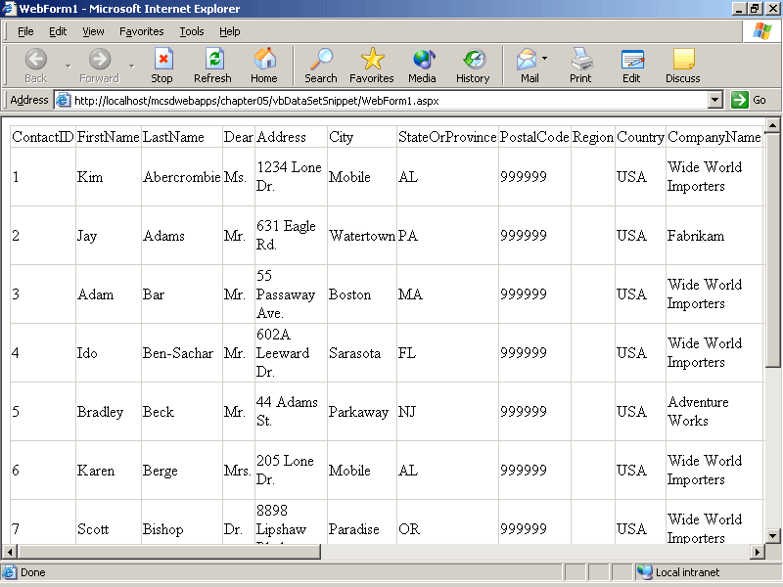
Figure 5-16. The DataGrid control without formatting
This is generally not what you want. For instance, the Birthdate column (not shown in Figure 5-16) includes a time as well as the date.
To select the columns you want to display and to format the data in the DataGrid control, follow these steps:
- Click the Property Builder link in the Properties window. Visual Studio displays the Properties dialog box for the DataGrid control.
- Select the Columns item on the left side of the Properties dialog box to select and format the columns of data displayed from the data set. Visual Studio displays the columns’ properties, as shown in Figure 5-17.
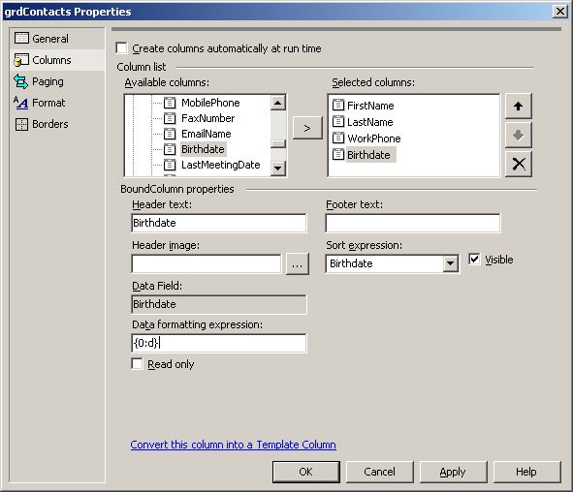
Figure 5-17. Specifying columns and formatting for a DataGrid control
To display specific columns from the data set, follow these steps:
- Clear the Create Columns Automatically At Run Time check box. This limits the columns in the DataGrid control to only the ones you select.
- Select the column in the Available Columns list, and click the Add (>) button to add the column to the Selected Columns list.
To format data in a column, follow these steps:
- Select the column to format in the Selected Columns list.
- Type the format expression in the Data Formatting Expression box. Data formatting expressions take the form:
{0:formattingexpression}
where formattingexpression is one of the predefined Microsoft .NET Framework format expressions, as described in the “Date and Time Format Strings,” “Numeric Format Strings,” and “Custom Format Strings” topics in the Visual Studio online Help.
You use the DataGrid Properties dialog box to specify all aspects of the appearance and behavior of the DataGrid, including formatting the column headings, specifying how the grid scrolls (pages) through records, specifying whether borders or rules are displayed, and much more.
Figure 5-18 shows the Contacts data set displayed in a DataGrid control with formatting applied. The DataGrid control displays only four columns from the data set and formats the Birthdate column as a short date ({0:d}).
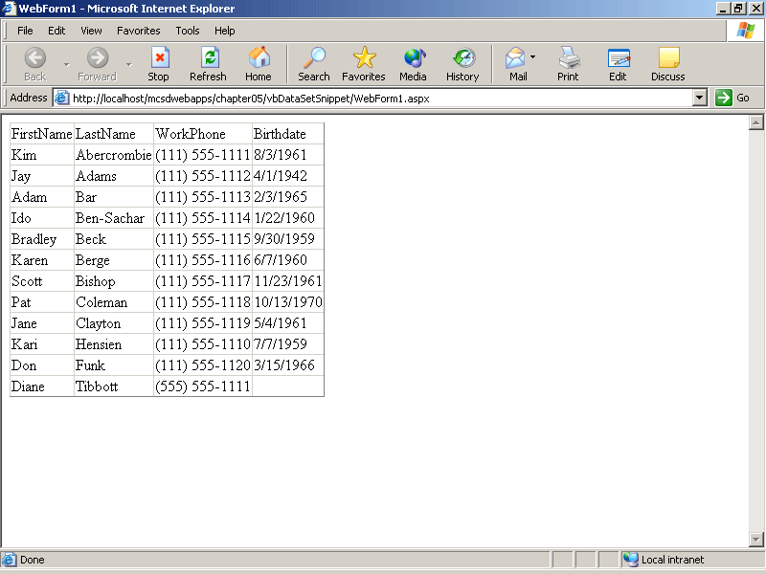
Figure 5-18. Selected columns from a data set with formatting applied
Displaying a Data Set in a DataList Control
Use the DataList control to display information from a data set as a list of rows, rather than rows and columns as in a DataGrid control.
To display a data set in a DataList control, follow these steps:
- Create the database connection, adapter, and data set objects as described in the previous lesson.
- Add a DataList control to the Web form.
- Set the DataSource property of the DataGrid control to the name of the data set.
- Add code to the Web form’s Page_Load event procedure to fill the data set from the adapter and to bind the data from the data set to the DataGrid control.
- Edit the DataList control’s header, item, and separator templates to create the appearance of the DataList.
The DataList control uses templates to determine the content of its headers, footers, and rows. You edit these templates to add literals and controls that bind to items in the data set. The DataList control provides three different categories of templates to control the different aspects of its appearance:
- Header and footer templates
These include the title and rule lines that appear at the top and the bottom of the DataList control.
- Items templates
These determine the contents of the rows in the data list and allow you to alternate the appearance of odd, even, selected, or edited rows.
- Separator templates
These add rule lines or other separators between rows.
To edit a DataList template:
- Right-click the DataList control, point to Edit Template, and then select the template to edit from the shortcut menu.
- The DataList control changes its appearance when it is in Edit mode, as shown in Figure 5-19. Type the text you want to appear in the template and add controls as desired.
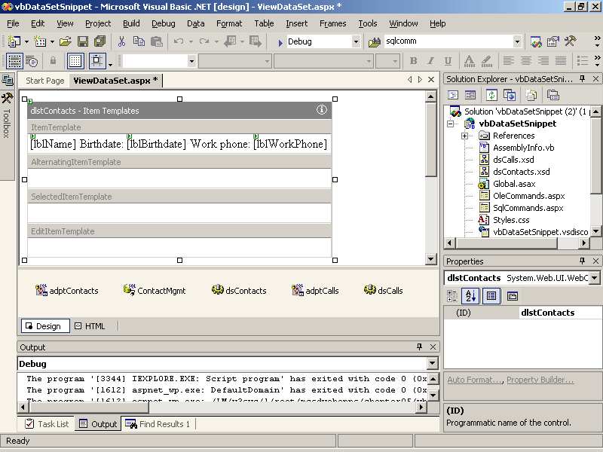
Figure 5-19. DataList control in template Edit mode
- To display an item from the data set in the template, add a control to the template, and then click the DataBindings property for the control. Click the ellipsis button to the right of the DataBindings property. Visual Studio displays the DataBindings dialog box for the control, as shown in Figure 5-20.
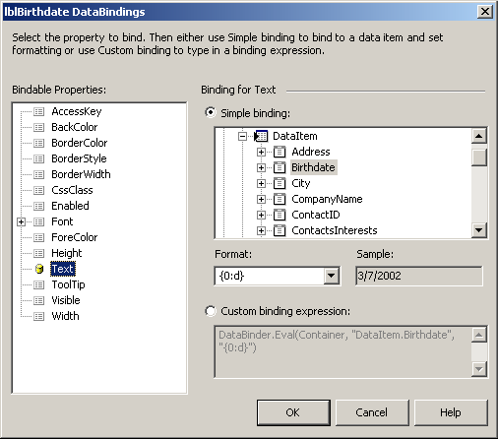
Figure 5-20. DataBindings dialog box
- When you have finished editing the DataList control’s templates, right-click the DataList control and select End Template Editing from the shortcut menu.
Data binding for controls in the DataList control’s Items template can be a simple binding to an item from the container, as shown in Figure 5-20, or it can be a more complex expression using the Eval method. For example, the following custom binding expression combines first name and last name information in a single control:
Visual Basic .NET
DataBinder.Eval(Container, "DataItem.FirstName") & " " & _
DataBinder.Eval(Container, "DataItem.LastName")
Visual C#
DataBinder.Eval(Container, "DataItem.FirstName") + " " +
DataBinder.Eval(Container, "DataItem.LastName");
The DataBinder object’s Eval method is actually what is generated by Visual Studio in the Web form’s HTML when you create a DataList control template with data binding. It is sometimes easier to edit templates directly in HTML than through the edit template procedure described previously.
To edit a DataList template directly in HTML, right-click the Web form and select View HTML Source from the shortcut menu. Visual Studio displays the Web form in HTML mode.
For example, the following HTML displays a DataList control that contains name, birthday, and telephone information from the Contacts data set:
<asp:DataList id="dlstContacts" runat="server" DataSource="<%# dsContacts1 %>">
<HeaderTemplate>
<h2>
Contact Information
<HR width="100%" SIZE="1">
</h2>
</HeaderTemplate>

<FooterTemplate>
<HR>
</FooterTemplate>

<ItemTemplate>
<asp:Label id="lblName" runat="server"
Text='<%# DataBinder.Eval(Container, "DataItem.FirstName") + " " + DataBinder.Eval(Container,"DataItem.LastName") %>'>
</asp:Label>
&nbsp;Birthdate:
<asp:Label id="lblBirthdate" runat="server"
Text='<%# DataBinder.Eval(Container, "DataItem.Birthdate",
"{0:d}") %>'>
</asp:Label>
&nbsp;Work phone:
<asp:Label id="lblWorkPhone" runat="server"
Text='<%# DataBinder.Eval(Container, "DataItem.WorkPhone") %>'>
</asp:Label>
</ItemTemplate>

<SeparatorTemplate>
<HR>
</SeparatorTemplate>
</asp:DataList>
To display the data set in the preceding control, fill the data set from the data adapter and bind to the DataList control, as shown by the following Page_Load event procedure:
Visual Basic .NET
Private Sub Page_Load(ByVal sender As System.Object, _
ByVal e As System.EventArgs) Handles MyBase.Load
' Fill the data set.
adptContacts.Fill(dsContacts1)
' Bind the data to the DataList control
dlstContacts.DataBind()
End Sub
Visual C#
private void Page_Load(object sender, System.EventArgs e)
{
// Fill the data set.
adptContacts.Fill(dsContacts1);
// Bind the data to the DataList control.
dlstContacts.DataBind();
}
At run time, the preceding DataList control displays the header, items, and separators, as shown in Figure 5-21.
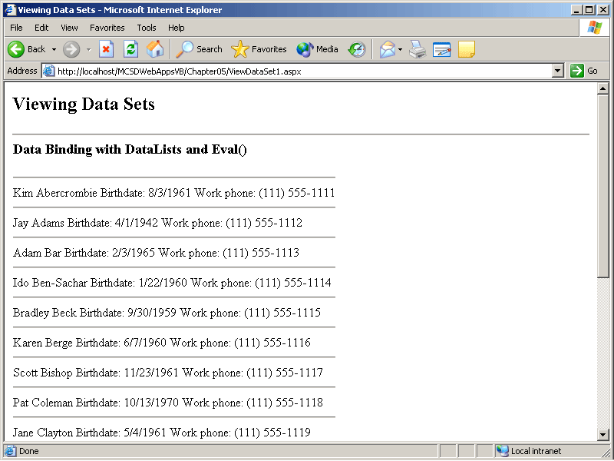
Figure 5-21. DataList control with data binding at run time
Displaying Data Items in Other List Controls
Of course, you can bind the items from a data set to any list control on a Web form. The DataGrid and DataList controls are just two of the most versatile ways to display a data set.
To display items from a data set in a ListBox, DropDownList, CheckBoxList, or RadioButtonList control, follow these steps:
- Set the control’s DataSource property to the name of the data set.
- Set the control’s DataText property to the data set member to display as the Text property of the list item.
- Set the control’s DataValue property to the data set member to return as the Value property of the list item.
- In code, fill the data set from data adapter and bind to the control.
The following HTML shows the property settings for a DropDownList control that is bound to the Contacts data set:
<asp:DropDownList id="drpContacts" runat="server" Width="384px" Height="22px"
DataSource="<%# dsContacts1 %>" DataTextField='LastName' DataValueField="ContactID"></asp:DropDownList>
The following code fills the data set and binds the data to the DropDownList control:
Visual Basic .NET
Private Sub Page_Load(ByVal sender As System.Object, _
ByVal e As System.EventArgs) Handles MyBase.Load
If Not IsPostBack Then
' Fill the data set.
adptContacts.Fill(dsContacts1)
' Bind the data to the control.
drpContacts.DataBind()
End If
End Sub
Visual C#
private void Page_Load(object sender, System.EventArgs e)
{
if (!IsPostBack)
{
// Fill the data set.
adptContacts.Fill(dsContacts1);
// Bind the data to the DataList control.
drpContacts.DataBind();
}
}
At run time, the DropDownList control displays a list of the last names from the Contacts table, and the SelectedItem.Value property returns the ContactID, which is useful for looking up other information about the individual.
The limitation here is that you can include only one value for the list control’s DataText and DataValue properties. If you want to include the first and last names of the contact in the DropDownList control, you have to do it from code. The following Page_Load event procedure adds the first and last names to the DropDownList control and includes the ContactID as the Value property for each list item:
Visual Basic .NET
Private Sub Page_Load(ByVal sender As System.Object, _
ByVal e As System.EventArgs) Handles MyBase.Load
' Run first time page is displayed.
If Not IsPostBack Then
' Fill the Contacts data set.
adptContacts.Fill(dsContacts1)
' For each row in the table...
Dim drowItem As dsContacts.ContactsRow
For Each drowItem In dsContacts1.Contacts
' Create a new list item.
Dim lstNew As New ListItem
lstNew.Text = drowItem.FirstName & " " & drowItem.LastName
lstNew.Value = drowItem.ContactID
' Add the list item to the drop-down list.
drpContacts.Items.Add(lstNew)
Next
End If
End Sub
Visual C#
private void Page_Load(object sender, System.EventArgs e)
{
// Run first time page is displayed.
if (!IsPostBack)
{
// Fill the Contacts data set.
adptContacts.Fill(dsContacts1);
// For each row in the table...
foreach (dsContacts.ContactsRow drowItem in dsContacts.Contacts)
{
// Create a new list item.
ListItem lstNew = new ListItem();
lstNew.Text = drowItem.FirstName + " " +
drowItem.LastName;
lstNew.Value = drowItem.ContactID.ToString();
// Add the list item to the drop-down list.
drpContacts.Items.Add(lstNew);
}
}
}
Selecting Specific Records
The DropDownList control created in the preceding section is useful for selecting items from the Calls table in the Contacts database. Because ContactID is a unique key in the database, you can use it to select the Call records for a specific contact. The following code builds a data set containing the calls for the contact selected from the DropDownList control:
Visual Basic .NET
Private Sub drpContacts_SelectedIndexChanged(ByVal sender As System.Object, _
ByVal e As System.EventArgs) Handles drpContacts.SelectedIndexChanged
' When a contact is selected, display the contact's calls.
adptCalls.SelectCommand.CommandText = "SELECT * FROM Calls" & _
" WHERE ContactID =" & drpContacts.SelectedItem.Value
adptCalls.Fill(dsCalls1)
If dsCalls1.Tables("Calls").Rows.Count > 0 Then
' Display the results in a data grid.
grdCalls.DataBind()
grdCalls.Visible = True
lblMsg.Text = ""
Else
grdCalls.Visible = False
lblMsg.Text = drpContacts.SelectedItem.Text + " has no calls."
End If
End Sub
Visual C#
private void drpContacts_SelectedIndexChanged(object sender, EventArgs e)
{
// When a contact is selected, display the contact's calls.
adptCalls.SelectCommand.CommandText = "SELECT * FROM Calls" +
" WHERE ContactID =" + drpContacts.SelectedItem.Value.ToString();
adptCalls.Fill(dsCalls1);
if (dsCalls1.Tables["Calls"].Rows.Count > 0)
{
// Display the results in a data grid.
grdCalls.DataBind();
grdCalls.Visible = true;
lblMsg.Text = "";
}
else
{
grdCalls.Visible = false;
lblMsg.Text = drpContacts.SelectedItem.Text + " has no calls.";
}
}
At run time, the Web form displays a list of the calls for the contact selected in the DropDownList control, as shown in Figure 5-22.
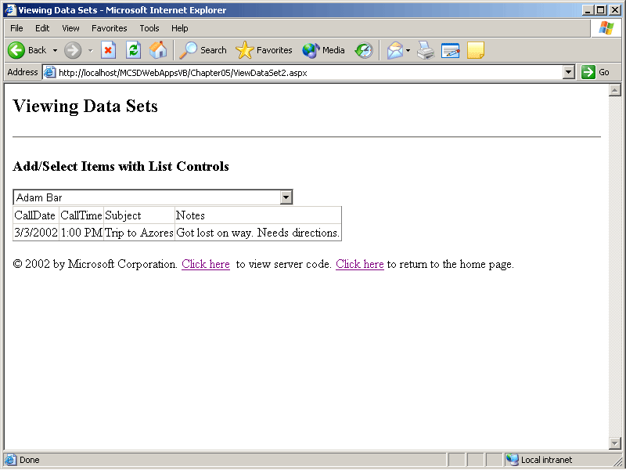
Figure 5-22. Selecting Records with a DropDownList control
Executing Commands on a Database
In addition to working with data sets, you can perform commands directly on a database connection. The database connection object provides these three command methods:
- ExecuteScalar
Performs query commands that return a single value, such as counting the number of records in a table.
- ExecuteNonQuery
Performs commands that change the database but do not return a specific value, including adding and deleting items from a database. The ExecuteNonQuery method returns the number of rows affected by the command.
- ExecuteReader
Reads records sequentially from the database.
To use these methods, follow these steps:
- Create a connection to the database.
- Open the connection.
- Create a command object containing the SQL command or stored procedure to execute.
- Execute the method on the command object.
- Close the database connection.
Because any command that executes on a database has at least some potential to fail, you should always use exception handling to ensure that the database connection is closed whether or not the command succeeds. Calling the connection’s Close method from a Finally/finally exception-handling clause ensures that the database connection is closed before the code continues.
Returning a Value from a Database
Use the ExecuteScalar method to execute a command that returns a single value from a database. For example, the following code executes a SQL MAX function to retrieve the highest number used for ContactID and then uses that value as the seed value for adding a new row to the Contacts table:
Visual Basic .NET
' Create a database connection.
Dim connContacts As New SqlConnection("integrated security=SSPI;" + _
"data source=(local);initial catalog=Contacts")

Private Sub butAdd_Click(ByVal sender As System.Object, _
ByVal e As System.EventArgs) Handles butAdd.Click
Try
' Create a SQL command to get a unique ContactID.
Dim cmdNewID As New SqlCommand("SELECT MAX(ContactID)" & _
" FROM Contacts", connContacts)
' Open the database connection.
connContacts.Open()
' Execute the SQL command.
Dim intNextID As Integer = CInt(cmdNewID.ExecuteScalar()) + 1
' Create a command to add a new row.
Dim cmdAddRow As New SqlCommand(String.Format("INSERT INTO " + _
"Contacts(ContactID, FirstName, LastName, WorkPhone) " + _
"VALUES({0}, '{1}', '{2}', '{3}')", intNextID, txtFirstName.Text, _
txtLastName.Text, txtPhone.Text), connContacts)
' Execute the command.
If cmdAddRow.ExecuteNonQuery Then
lblMsg.Text = "Record added."
Else
lblMsg.Text = "Couldn't add record."
End If
Catch ex As Exception
lblMsg.Text = "Couldn't access database due to this error: " + _
ex.Message
Finally
' Close connection
connContacts.Close()
End Try
End Sub
Visual C#
SqlConnection connContacts = new SqlConnection("integrated security=SSPI;" +
"data source=(local);initial catalog=Contacts");

private void butAdd_Click(object sender, System.EventArgs e)
{
try
{
// Create a SQL command to get a unique ContactID.
SqlCommand cmdNewID =new SqlCommand("SELECT MAX(ContactID)" +
" FROM Contacts", connContacts);
// Open the database connection.
connContacts.Open();
// Execute the SQL command.
int intNextID = (int)cmdNewID.ExecuteScalar() + 1;
// Create a command to add a new row.
SqlCommand cmdAddRow = new SqlCommand(String.Format("INSERT " +
"INTO Contacts(ContactID, FirstName, LastName, WorkPhone) " +
"VALUES({0}, '{1}', '{2}', '{3}')", intNextID,
txtFirstName.Text, txtLastName.Text,
txtPhone.Text), connContacts);
// Execute the command.
if (cmdAddRow.ExecuteNonQuery() > 0)
{
lblMsg.Text = "Record added.";
// Database changed, so refresh list.
RefreshList();
// Clear text boxes.
ClearText();
}
else
{
lblMsg.Text = "Couldn't add record.";
}
}
catch (Exception ex)
{
lblMsg.Text = "Couldn't access database due to this error: " +
ex.Message;
}
finally
{
// Close connection
connContacts.Close();
}
}
The ExecuteScalar method can be used with any SQL statement that returns a single value. To execute other types of SQL statements, use the ExecuteNonQuery or ExecuteReader method.
Changing Records Directly in a Database
The ExecuteNonQuery method performs commands that do not return a data set, such as SQL INSERT, DELETE, or UPDATE. For example, the following code uses ExecuteNonQuery to delete a row directly from the database:
Visual Basic .NET
' Create a database connection.
Dim connContacts As New SqlConnection("integrated security=SSPI;" + _
"data source=(local);initial catalog=Contacts")

Private Sub butDelete_Click(ByVal sender As System.Object, _
ByVal e As System.EventArgs) Handles butDelete.Click
Try
' Create a SQL command to delete record.
Dim sqlDelete As New _
SqlCommand("DELETE FROM Contacts WHERE ContactID=" + _
lblContactID.Text, connContacts)
' Open the database connection
connContacts.Open()
' Execute the command.
If sqlDelete.ExecuteNonQuery Then
lblMsg.Text = "Record deleted."
Else
lblMsg.Text = "Couldn't find record to delete."
End If
Catch ex As Exception
lblMsg.Text = "Couldn't access database due to this error: " + _
ex.Message
Finally
' Close connection
connContacts.Close()
End Try
End Sub
Visual C#
SqlConnection connContacts = new SqlConnection("integrated security=SSPI;" +
"data source=(local);initial catalog=Contacts");

private void butDelete_Click(object sender, System.EventArgs e)
{
try
{
// Create a SQL command to delete record.
SqlCommand sqlDelete = new SqlCommand("DELETE FROM Contacts " +
"WHERE ContactID=" + lblContactID.Text, connContacts);
// Open the database connection
connContacts.Open();
// Execute the command.
if (sqlDelete.ExecuteNonQuery() > 0)
{
lblMsg.Text = "Record deleted.";
// Database changed, so refresh list.
RefreshList();
// Clear text boxes
ClearText();
}
else
{
lblMsg.Text = "Couldn't find record to delete.";
}
}
catch (Exception ex)
{
lblMsg.Text = "Couldn't access database due to this error: " +
ex.Message;
}
finally
{
// Close connection
connContacts.Close();
}
}
The ExecuteNonQuery method acts directly on the database connection—it does not go through a data adapter or a data set. If you make changes to a table in the database through ExecuteNonQuery, you must update any data sets affected by those changes by calling the Fill method on the data adapter.
Retrieving Records Directly from the Database
The ExecuteReader method performs commands that return records, such as SQL SELECT. Each record is returned as a data reader object, which is sort of a read-only version of a data set. Because the ExecuteReader method acts directly on the database connection, there are two versions of the data reader object: OleDbDataReader and SqlDataReader.
Using ExecuteReader to create data reader objects provides better performance than creating a data set from a data adapter object, but it doesn’t provide you with much flexibility. Data reader objects are read-only and they only read forward, one record at a time. Data sets allow you to get records in any order and, more important, allow you to write changes back to the database.
The following code gets all the contacts and displays their names in a drop-down list using a data reader object and the Execute reader command:
Visual Basic .NET
' Create a database connection.
Dim connContacts As New SqlConnection("integrated security=SSPI;" + _
"data source=(local);initial catalog=Contacts")

Private Sub Page_Load(ByVal sender As System.Object, _
ByVal e As System.EventArgs) Handles MyBase.Load
' Get values for drop-down list the first time
' the page is displayed.
If Not IsPostBack Then
RefreshList()
End If
End Sub

' Loads values from database into a drop-down list.
Sub RefreshList()
Try
' Clear the list
drpContacts.Items.Clear()
' Create SQL command to get table.
Dim cmdGetContacts As New SqlCommand("Select * From Contacts", _
connContacts)
' Open database connection if it is closed.
If connContacts.State = ConnectionState.Closed Then _
connContacts.Open()
' Execute command.
Dim readContacts As SqlDataReader = cmdGetContacts.ExecuteReader()
' Read the names and contact IDs into a drop-down list
Do While readContacts.Read()
' Create a new list item.
Dim NewItem As New ListItem
' Set the item's values.
NewItem.Text = readContacts.GetString(1) + " " _
+ readContacts.GetString(2)
NewItem.Value = readContacts.GetValue(0)
' Add the new item to the list.
drpContacts.Items.Add(NewItem)
Loop
Catch ex As Exception
lblMsg.Text = "Couldn't access data due to this error: " + _
ex.Message
Finally
' Close the connection.
connContacts.Close()
End Try
End Sub
Visual C#
SqlConnection connContacts = new SqlConnection("integrated security=SSPI;" +
"data source=(local);initial catalog=Contacts");

private void Page_Load(object sender, System.EventArgs e)
{
// Get values for drop-down list the first time
// the page is changed.
if (!IsPostBack)
{
RefreshList();
}
}

private void RefreshList()
{
try
{
// Clear the list
drpContacts.Items.Clear();
// Create SQL command to get table.
SqlCommand cmdGetContacts = new SqlCommand("Select * " +
"From Contacts", connContacts);
// Open database connection if it is closed.
if (connContacts.State == ConnectionState.Closed)
connContacts.Open();
// Execute command.
SqlDataReader readContacts = cmdGetContacts.ExecuteReader();
// Read the names and contact IDs into a drop-down list
while (readContacts.Read())
{
// Create a new list item.
ListItem NewItem = new ListItem();
// Set the item's values.
NewItem.Text = readContacts.GetString(1) + " "
+ readContacts.GetString(2);
NewItem.Value = readContacts.GetValue(0).ToString();
// Add the new item to the list.
drpContacts.Items.Add(NewItem);
}
}
catch (Exception ex)
{
lblMsg.Text = "Couldn't access data due to this error: " +
ex.Message;
}
finally
{
// Always close the connection.
connContacts.Close();
}
}
The data reader object is a read-forward set of records, so the Read method reads each subsequent line until it reaches the end of the record set. A reader object locks the database connection while it is executing, so you should call the reader object’s Close method when you have finished getting records, as shown in the preceding code.
Executing Stored Procedures
One well-known performance tip when you’re working with databases is to move frequently used tasks into stored procedures. Stored procedures execute within the context of the database manager and therefore can be optimized for ideal performance.
Use the ExecuteScalar, ExecuteNonQuery, or ExecuteReader method to run stored procedures. For example, the following code executes a stored procedure that returns the ten most expensive products in the Northwind Traders database.
Visual Basic .NET
Private Sub butExecute_Click(ByVal sender As System.Object, _
ByVal e As System.EventArgs) Handles butExecute.Click
' Create a connection for NorthWind Traders database.
Dim connNWind As New SqlConnection("integrated security=SSPI;" + _
"data source=(local);initial catalog=Northwind")
' Create a command object to execute.
Dim cmdTopTen As New SqlCommand("Ten Most Expensive Products", _
connNWind)
' Set the command properties.
cmdTopTen.CommandType = CommandType.StoredProcedure
' Create a data reader object to get the results.
Dim drdTopTen As SqlDataReader
' Open the connection.
connNWind.Open()
Try
' Excecute the stored procedure.
drdTopTen = cmdTopTen.ExecuteReader()
' Display a header.
litData.Text = "<h3>Ten Most Expensive Products:</h3>"
' Display the results on the page.
Do While drdTopTen.Read()
' Create an array to receive data.
Dim items() As Object = {"", "", "", "", "", ""}
' If the row contains items.
If drdTopTen.GetValues(items) > 0 Then
Dim item As Object
' Get each row item and add it to the literal control.
For Each item In items
litData.Text += item.ToString + " "
Next
' Add a break between rows.
litData.Text += "<br>"
End If
Loop
Catch ex As Exception
litData.Text = "The following error occurred: <br>"
litData.Text += ex.Message
Finally
' Close the connection.
connNWind.Close()
End Try
End Sub
Visual C#
private void butExecute_Click(object sender, System.EventArgs e)
{
// Create a connection for NorthWind Traders database.
SqlConnection connNWind = new SqlConnection("integrated " +
"security=SSPI;data source=(local);initial catalog=Northwind");
// Create a command object to execute.
SqlCommand cmdTopTen = new SqlCommand("Ten Most Expensive Products",
connNWind);
// Set the command properties.
cmdTopTen.CommandType = CommandType.StoredProcedure;
// Create a data reader object to get the results.
SqlDataReader drdTopTen;
// Open the connection.
connNWind.Open();
try
{
// Excecute the stored procedure.
drdTopTen = cmdTopTen.ExecuteReader();
// Display a header.
litData.Text = "<h3>Ten Most Expensive Products:</h3>";
// Display the results on the page.
while (drdTopTen.Read())
{
// Create an array to receive data.
object[] items = {"", "", "", "", "", ""};
// If the row contains items.
if (drdTopTen.GetValues(items) > 0)
{
// Add each row item to the literal control.
foreach(object item in items)
litData.Text += item.ToString() + " ";
// Add a break between rows.
litData.Text += "<br>";
}
}
}
catch (Exception ex)
{
litData.Text = "The following error occurred: <br>";
litData.Text += ex.Message;
}
finally
{
// Close the connection.
connNWind.Close();
}
}
Lesson 3: Processing Transactions
ADO.NET lets you group database operations into transactions. A transaction is a group of commands that change the data stored in a database. The transaction, which is treated as a single unit, assures that the commands are handled in an all-or-nothing fashion—if one of the commands fails, all of the commands fail, and any data that was written to the database by the commands is backed out. In this way, transactions maintain the integrity of data in a database.
In this lesson, you’ll learn how to implement transaction processing in a Web application for data sets and for databases.
After this lesson, you will be able to
- Understand the importance of transaction processing for Web applications that use data access
- Explain the levels of transaction processing that ADO.NET supports
- Manage changes to a data set as a transaction
- Create transaction objects for a database
- Track commands performed on a database through a transaction object
- Commit or roll back (undo) changes to a database using the transaction object
Estimated lesson time: 30 minutes
Understanding Transactions
As stated earlier, a transaction is a group of database commands that are treated as a single unit. Database programmers determine what database commands belong in a transaction by using the ACID test: commands must be atomic, consistent, isolated, and durable. Commands belong in a transaction if they are:
- Atomic
In other words, they make up a single unit of work. For example, if a customer moves, you want your data entry operator to change all of the customer’s address fields as a single unit, rather than changing street, then city, then state, and so on.
- Consistent
All the relationships between data in a database are maintained correctly. For example, if customer information uses a tax rate from a state tax table, the state entered for the customer must exist in the state tax table.
- Isolated
Changes made by other clients can’t affect the current changes. For example, if two data entry operators try to make a change to the same customer at the same time, one of two things occurs: either one operator’s changes are accepted and the other is notified that the changes weren’t made, or both operators are notified that their changes were not made. In either case, the customer data is not left in an indeterminate state.
- Durable
Once a change is made, it is permanent. If a system error or power failure occurs before a set of commands is complete, those commands are undone and the data is restored to its original state once the system begins running again.
Transaction processing is particularly important for Web applications that use data access, because Web applications are distributed among many different clients. In a Web application, databases are a shared resource, and having many different clients distributed over a wide area can present these key problems:
- Contention for resources
Several clients might try to change the same record at the same time. This problem gets worse the more clients you have.
- Unexpected failures
The Internet is not the most reliable network around, even if your Web application and Web server are 100 percent reliable. Clients can be unexpectedly disconnected by their service providers, by their modems, or by power failures.
- Web application life cycle
Web applications don’t follow the same life cycle as Windows applications—Web forms live for only an instant, and a client can leave your application at any point by simply typing a new address in his or her browser.
Transaction processing follows these steps:
- Begin a transaction.
- Process database commands.
- Check for errors.
- If errors occurred, restore the database to its state at the beginning of the transaction. If no errors occurred, commit the transaction to the database.
In ADO.NET, transactions are handled in different ways, depending on the level you’re working at:
- Data sets provide transaction processing through the RejectChanges and Update methods.
Data sets also provide an AcceptChanges method that resets the state of records in a data set to Unchanged.
- Database connection objects provide transaction processing through the Transaction object.
Transaction objects track commands performed on a database and provide the Rollback, Commit, and Save methods to restore database state, commit changes, or create a save point within a transaction, respectively.
- The System.EnterpriseServices namespace provides enterprise-level transactions through the ContextUtil class.
Enterprise-level transactions use the Microsoft Distributed Transaction Coordinator (MS DTC) provided with Microsoft SQL Server 2000 to track transactions across multiple Web forms and across multiple COM+ components.
Data Set Transactions
Data sets provide implicit transaction processing, because changes to a data set are not made in the database until you invoke the Update method on the data adapter object. This lets you perform a set of commands on the data and then choose a point at which to make the changes permanent in the database.
If an error occurs during the Update method, none of the changes from the data set is made in the database. At that point, you can either attempt to correct the error and try the Update method again or undo the changes pending in the data set using the data set’s RejectChanges method. For example, the following code displays the Contacts list in a DataGrid control and allows the user to delete rows by clicking Delete in the DataGrid:
Visual Basic .NET
Private Sub Page_Load(ByVal sender As System.Object, _
ByVal e As System.EventArgs) Handles MyBase.Load
' Check if this is the first time page is displayed.
If Not IsPostBack Then
' On first display:
' Fill the data set.
adptContacts.Fill(dsContacts)
' Save data set as state variable.
Session("dsContacts") = dsContacts
Else
' On subsequent displays:
' Get the data set from the state variable.
dsContacts = Session("dsContacts")
End If
' Bind to data set.
grdContacts.DataBind()
End Sub

Private Sub grdContacts_ItemCommand(ByVal source As Object, _
ByVal e As System.Web.UI.WebControls.DataGridCommandEventArgs) _
Handles grdContacts.ItemCommand
' If the Delete button was clicked.
If e.CommandName = "Delete" Then
Dim intContactID
' Get selected row's ContactID.
intContactID = _
CInt(grdContacts.Items(e.Item.ItemIndex).Cells(3).Text)
Dim rowDelete As dsContacts.ContactsRow
' Get the row to delete from the data set.
rowDelete = dsContacts.Contacts.FindByContactID(intContactID)
' Delete the row.
rowDelete.Delete()
' Refresh the data grid.
grdContacts.DataBind()
End If
End Sub
Visual C#
private void Page_Load(object sender, System.EventArgs e)
{
// Check if this is the first time page is displayed.
if (!IsPostBack)
{
// On first display:
// Fill the data set.
adptContacts.Fill(dsContacts);
// Save data set as state variable.
Session["dsContacts"] = dsContacts;
}
else
// On subsequent displays:
// Get the data set from the state variable.
dsContacts = (dsContacts)Session["dsContacts"];
// Bind to data set.
grdContacts.DataBind();
}

private void grdContacts_ItemCommand(object sender,
System.Web.UI.WebControls.DataGridCommandEventArgs e)
{
// If the Delete button was clicked.
if (e.CommandName == "Delete")
{
int intContactID;
// Get selected row's ContactID.
intContactID = Convert.ToInt16
(grdContacts.Items[e.Item.ItemIndex].Cells[3].Text);
dsContacts.ContactsRow rowDelete;
// Get the row to delete from the data set.
rowDelete = dsContacts.Contacts.FindByContactID(intContactID);
// Delete the row.
rowDelete.Delete();
// Refresh the data grid.
grdContacts.DataBind();
}
}
The following event procedures for the Restore and Commit buttons let the user restore the data set to its previous state or, alternatively, update the database with the deletions made in the preceding code:
Visual Basic .NET
Private Sub butRestore_Click(ByVal sender As System.Object, _
ByVal e As System.EventArgs) Handles butRestore.Click
' Restore the data set to its original state.
dsContacts.RejectChanges()
' Refresh the data grid.
grdContacts.DataBind()
End Sub

Private Sub butCommit_Click(ByVal sender As System.Object, _
ByVal e As System.EventArgs) Handles butCommit.Click
' Update the database from the data set.
adptContacts.Update(dsContacts)
' Save changes to state variable.
Session("dsContacts") = dsContacts
' Refresh the data grid.
grdContacts.DataBind()
End Sub
Visual C#
private void butRestore_Click(object sender, System.EventArgs e)
{
// Restore the data set to its original state.
dsContacts.RejectChanges();
// Refresh the data grid.
grdContacts.DataBind();
}

private void butCommit_Click(object sender, System.EventArgs e)
{
int intRows;
// Update the database from the data set.
intRows = adptContacts.Update(dsContacts);
// Save changes to state variable.
Session["dsContacts"] = dsContacts;
// Refresh the data grid.
grdContacts.DataBind();
}
The RejectChanges method in the preceding butRestore_Click event procedure returns the data set to its state before the row was deleted. The data set’s AcceptChanges method is the inverse of RejectChanges—it resets the DataRowState property for all the changed rows in a data set to Unchanged and removes any deleted rows.
The AcceptChanges method prevents the Update method from making those changes in the database, however, because Update uses the rows’ DataRowState property to determine which rows to modify in the database. For this reason, the AcceptChanges method is useful only when you do not intend to update a database from the data set.
Database Transactions
You can manage transactions at the database level through a transaction object. Since there are three types of database connections in ADO.NET, there are also three types of transaction object: SqlTransaction, OracleTransaction, and OleDbTransaction.
To use either type of transaction object, follow these steps:
- Open a database connection.
- Create the transaction object using the database connection object’s BeginTransaction method.
- Create command objects to track with this transaction, assigning the Transaction property of each command object to the name of the transaction object created in step 2.
- Execute the commands. Because the purpose of transaction processing is to detect and correct errors before data is written to the database, this is usually done as part of an error-handling structure.
- Commit the changes to the database or restore the database state, depending on the success of the commands.
- Close the database connection.
The following code uses a DataGrid control to display a list of contacts from the Contacts database. The DataGrid control includes a column of buttons that allow the user to delete contacts. The DeleteContact function uses a transaction to ensure that a contact’s calls are deleted if the contact is deleted. This helps ensure the integrity of the database.
Visual Basic .NET
Private Sub Page_Load(ByVal sender As System.Object, _
ByVal e As System.EventArgs) Handles MyBase.Load
' Fill the data set.
adptContacts.Fill(dsContacts)
' Bind to data set.
grdContacts.DataBind()
End Sub

Private Sub grdContacts_ItemCommand(ByVal source As Object, _
ByVal e As System.Web.UI.WebControls.DataGridCommandEventArgs) _
Handles grdContacts.ItemCommand
' If the Delete button was clicked.
If e.CommandName = "Delete" Then
Dim intContactID
' Get selected row's ContactID.
intContactID = _
CInt(grdContacts.Items(e.Item.ItemIndex).Cells(3).Text)
' Delete the contact information.
lblStatus.Text = DeleteContact(intContactID)
End If
' Refresh the data set.
adptContacts.Fill(dsContacts)
' Refresh the DataGrid.
grdContacts.DataBind()
End Sub

Function DeleteContact(ByVal intContactID As Integer) As String
' Open the database connection.
ContactMgmt.Open()
' Declare a transaction object.
Dim transDelete As SqlTransaction
' Create the tranasction.
transDelete = ContactMgmt.BeginTransaction _
(IsolationLevel.ReadCommitted)
' Create the command to delete from Contacts table.
Dim cmdDelete As New SqlCommand("DELETE FROM Contacts" & _
" WHERE ContactID=" & intContactID, _
ContactMgmt, transDelete)
' Execute the commands
Try
Dim intRows As Integer
' Delete row from Contacts table.
intRows = cmdDelete.ExecuteNonQuery()
' Delete Calls for this ContactID.
cmdDelete.CommandText = "DELETE FROM Calls WHERE " & _
" ContactID=" & intContactID
intRows = intRows + cmdDelete.ExecuteNonQuery()
' Commit the transaction.
transDelete.Commit()
' Return success message.
Return intRows & " deleted."
Catch
' Restore the database state if there was an error.
transDelete.Rollback()
' Return error message.
Return "Contact could not be deleted."
Finally
' Close the database.
ContactMgmt.Close()
End Try
End Function
Visual C#
private void Page_Load(object sender, System.EventArgs e)
{
// Fill the data set.
adptContacts.Fill(dsContacts);
// Bind to the data set.
grdContacts.DataBind();
}

private void grdContacts_ItemCommand(object sender,
System.Web.UI.WebControls.DataGridCommandEventArgs e)
{
// If the Delete button was clicked.
if (e.CommandName == "Delete")
{
int intContactID;
// Get selected row's ContactID.
intContactID = Convert.ToInt16(grdContacts.Items
[e.Item.ItemIndex].Cells[3].Text);
// Delete the contact information.
lblStatus.Text = DeleteContact(intContactID);
}
// Refresh the data set.
adptContacts.Fill(dsContacts);
// Refresh the data grid.
grdContacts.DataBind();
}

string DeleteContact(int intContactID)
{
// Open the database connection.
ContactMgmt.Open();
// Declare a transaction object.
SqlTransaction transDelete;
// Create the tranasction.
transDelete = ContactMgmt.BeginTransaction
(IsolationLevel.ReadCommitted);
// Create the command to delete from Contacts table.
SqlCommand cmdDelete = new SqlCommand("DELETE FROM Contacts" +
" WHERE ContactID=" + intContactID.ToString(),
ContactMgmt, transDelete);
// Execute the commands
try
{
int intRows;
// Delete row from Contacts table.
intRows = cmdDelete.ExecuteNonQuery();
// Delete Calls for this ContactID.
cmdDelete.CommandText = "DELETE FROM Calls WHERE " +
" ContactID=" + intContactID.ToString();
intRows = intRows + cmdDelete.ExecuteNonQuery();
// Commit the transaction.
transDelete.Commit();
// Return success message.
return intRows.ToString() + " deleted.";
}
catch
{
// Restore the database state if there was an error.
transDelete.Rollback();
// Return error message.
return "Contact could not be deleted.";
}
finally
{
// Close the database.
ContactMgmt.Close();
}
}
The transaction object determines how concurrent changes to a database are handled through the IsolationLevel property. The level of protection varies, as specified by the settings described in Table 5-2.
Table 5-2. Isolation Level Settings
Isolation level | Behavior
ReadUncommitted | Does not lock the records being read. This means that an uncommitted change can be read and then rolled back by another client, resulting in a local copy of a record that is not consistent with what is stored in the database. This is called a dirty read because the data is inconsistent.
Chaos | Behaves the same way as ReadUncommitted, but checks the isolation level of other pending transactions during a write operation so that transactions with more restrictive isolation levels are not overwritten.
ReadCommitted | Locks the records being read and immediately frees the lock as soon as the records have been read. This prevents any changes from being read before they are committed, but it does not prevent records from being added, deleted, or changed by other clients during the transaction. This is the default isolation level.
RepeatableRead | Locks the records being read and keeps the lock until the transaction completes. This ensures that the data being read does not change during the transaction.
Serializable | Locks the entire data set being read and keeps the lock until the transaction completes. This ensures that the data and its order within the database do not change during the transaction.
SQL database connections provide one transaction capability that is unavailable for OLE database connections: the ability to create save points within a transaction. Save points let you restore the database state to a specific position within the current transaction. To set a save point within a SQL transaction, use the Save method:
Visual Basic .NET
transDelete.Save("FirstStep")
Visual C#
transDelete.Save("FirstStep");
To restore a SQL transaction to a save point, specify the name of the save point in the Rollback method:
Visual Basic .NET
transDelete.Rollback("FirstStep")
Visual C#
transDelete.Rollback("FirstStep");
Enterprise Transactions
Because transactions can span multiple Web forms, or even multiple components within a distributed application, ASP.NET provides a way for Web forms to work with MS DTC.
To use MS DTC from a Web form, follow these steps:
- Start a new transaction or continue an existing transaction by setting the document element’s Transaction attribute. For example, the following @ Page directive starts a new transaction:
- <%@ Page Language="vb" AutoEventWireup="false"
- Codebehind="Transaction3.aspx.vb"
- Inherits="MCSDWebAppsVB.Transaction3"
Transaction="RequiresNew"%>
- Add a reference to the System.EnterpriseServices namespace to your project.
- Use the ContextUtil class’s SetAbort and SetComplete methods to change the status of the transaction as required.
- Use the Page class’s CommitTransaction and AbortTransaction events to respond to changes in the transaction’s status.
See the Visual Studio .NET online Help for more information about MS DTC.
Summary
- ADO.NET includes five key components used for most data access: database connection, data adapter, data set, data table, and data view.
- ADO.NET provides typed data sets. Typed data sets use explicit names and data types that help prevent errors during programming.
- Use data binding to quickly display data sets on Web forms through the DataGrid, DataList, or other list controls.
- Create command objects to execute SQL commands directly on a database. Command objects can return a single value (ExecuteScalar), modify the database (ExecuteNonQuery), or return data (ExecuteReader).
- Transactions group database commands so that they succeed or fail in an all-or-nothing fashion. This ensures that changes are not partially made, thus preserving the integrity of the database.
- To determine which commands should be included in a transaction, use the ACID test. A transaction must be atomic, consistent, isolated, and durable.
- To use a transaction, follow these steps:
  - Begin the transaction.
  - Perform commands and make changes that are part of the transaction.
  - Check for errors.
  - If errors occurred, undo (roll back) the changes. If no errors occurred, commit the changes. This ends the transaction.
- Manage data set transactions using the Update method to commit changes and the RejectChanges method to undo (or roll back) changes.
- Manage database transactions using the transaction object’s Commit and Rollback methods.
Lab: Building the Contact Management Application
In this lab, you’ll create a multipage Web application that uses a database to store contact and call information. The application lets you add contacts, view and add calls made by a contact, and add new contact types. This application uses the Contacts SQL database installed by Setup on the companion CD.
The Contact Management application demonstrates these key concepts:
- Navigation
Users navigate from a central switchboard page to specific task pages. After users have finished a task, they navigate back to the switchboard page.
- Central data connection
The database connection, data adapter, and data set components reside in the Switchboard Web form. These objects are shared between Web forms using the application’s Cache object.
- Data set transactions
All changes to the database are processed through data sets, and all updates are contained within error-handling structures. If an update fails, the user can try again or cancel the operation without damaging the integrity of the database.
- Bound and unbound controls
Calls are displayed using a DataList control containing data-bound label controls. Contacts are displayed in a DropDownList control using code rather than data binding.
Estimated lesson time: 60 minutes
Exercise 1: Start a Project and Create the SwitchBoard Form

In this exercise, you start a new project and create the Web form used to navigate to the other Web forms in the application.
When you have finished creating the SwitchBoard form, it will appear as shown in Figure 5-23.
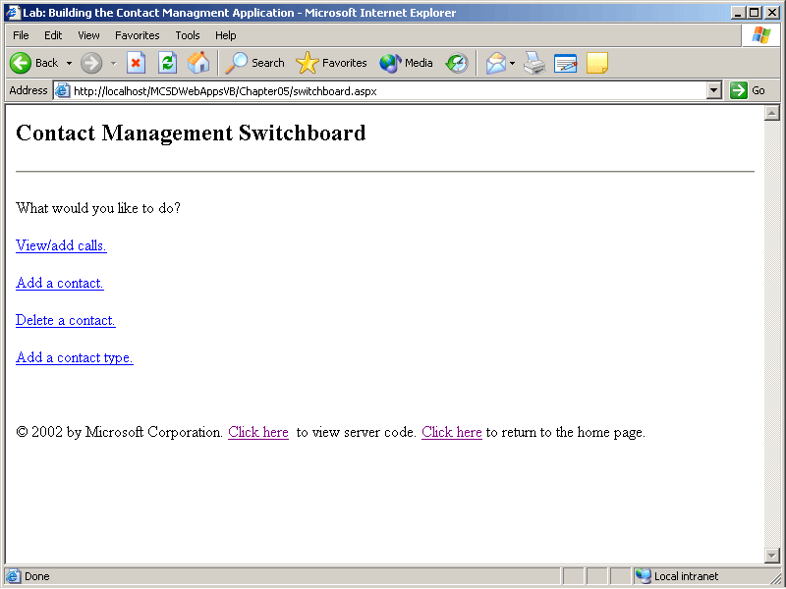
Figure 5-23. The SwitchBoard form
To start the new application and create the SwitchBoard Web form
- Create a new ASP.NET Web application project named ContactManagement.
- Change the name of the Webform1.aspx file to SwitchBoard.aspx, and display the Web form in HTML mode.
- Type the following HTML between the <form> and </form> tags:
- <h2>Contact Management Switchboard</h2>
- <P>What would you like to do? </P>
- <P><a href="Calls.aspx">View/add calls.</a></P>
- <P><a href="AddContact.aspx">Add a contact.</a></P>
- <P><a href="DeleteContact.aspx">Delete a contact.</a></P>
<P><a href="ContactTypes.aspx">Add a contact type.</a></P>
Exercise 2: Add Database Components
The Contact Management application performs data access from several different Web forms. The database connection, adapter, and data set components are added to the SwitchBoard Web form and saved as Cache variables so that they can be accessed from the other Web forms.
All the Web forms, and all users of the application, share a single database connection. This improves performance and makes it easier to maintain connection and adapter settings while developing the application because the database components are all located in one place: the SwitchBoard.aspx file.
To add the database components for the Contact Management application
- Open the SwitchBoard Web form in the Design window and click the Server Explorer link. Visual Studio displays the Server Explorer.
- Click the Connect To A Database button in the Server Explorer window. Visual Studio displays the Data Link Properties dialog box.
- Select the name of the SQL server where the Contacts sample database is installed, choose the Use Windows NT integrated security option, and then type Contacts in the Select The Database On The Server box. Click Test Connection to verify your settings, and then click OK when you have finished. Visual Studio adds the database connection to the Server Explorer.
- In the Server Explorer window, expand the items under the data connection you created by clicking the plus signs to the left of the Contacts.dbo data connection, and then do the same to the Tables subitem. Drag the Calls, ContactTypes, and Contacts tables from the Server Explorer to the SwitchBoard Web form. Visual Studio adds a database connection component and data adapter components for each of the tables.
- Each data adapter represents one of the tables you dragged onto the page. Right-click one of the data adapters and select Generate Data Set from the shortcut menu. Visual Studio displays the Generate DataSet dialog box.
- Type the name of the data set to create in the New text box. Name the data set after the table it represents (for example, dsCalls for the Calls table), and then select the Add This Dataset To The Designer check box and click OK. Visual Studio adds the data set to the SwitchBoard Web form.
NOTE
When Visual Studio adds a data set, it appends a number to the name you provide.
- Repeat steps 5 and 6 for each of the data adapters.
- Double-click the SwitchBoard Web form in the Design window to display the code for the page. Add the following Page_Load event procedure to create the Cache variables that you’ll use from subsequent Web forms to access the database components:
Visual Basic .NET
Private Sub Page_Load(ByVal sender As System.Object, _
ByVal e As System.EventArgs) Handles MyBase.Load
' The first time this page is displayed...
If Not IsPostBack Then
AddToCache("adptCalls", SqlDataAdapter1)
AddToCache("adptContactTypes", SqlDataAdapter2)
AddToCache("adptContacts", SqlDataAdapter3)
' Fill data sets and add them to Cache.
SqlDataAdapter1.Fill(DsCalls1)
AddToCache("dsCalls", DsCalls1)
SqlDataAdapter2.Fill(DsContactTypes1)
AddToCache("dsContactTypes", DsContactTypes1)
SqlDataAdapter3.Fill(DsContacts1)
AddToCache("dsContacts", DsContacts1)
End If
End Sub

Sub AddToCache(ByVal Name As String, ByVal Item As Object)
' If item is already in cache, simply return.
If Not IsNothing(Cache(Name)) Then Return
' Otherwise, cache the item for 20 minutes with sliding expiration.
Cache.Add(Name, Item, Nothing, DateTime.MaxValue, _
System.TimeSpan.FromMinutes(20), _
Caching.CacheItemPriority.Default, Nothing)
End Sub
Visual C#
private void Page_Load(object sender, System.EventArgs e)
{
// The first time this page is displayed...
if (!IsPostBack)
{
AddToCache("adptCalls", sqlDataAdapter1);
AddToCache("adptContactTypes", sqlDataAdapter2);
AddToCache("adptContacts", sqlDataAdapter3);
// Fill data sets and add them to Cache.
sqlDataAdapter1.Fill(dsCalls1);
AddToCache("dsCalls", dsCalls1);
sqlDataAdapter2.Fill(dsContactTypes1);
AddToCache("dsContactTypes", dsContactTypes1);
sqlDataAdapter3.Fill(dsContacts1);
AddToCache("dsContacts", dsContacts1);
}
}

void AddToCache(string Name, object Item)
{
// If item is already in cache, simply return.
if (Cache[Name] != null) return;
// Otherwise, cache the item for 20 minutes with sliding expiration.
Cache.Add(Name, Item, null, DateTime.MaxValue,
System.TimeSpan.FromMinutes(20),
System.Web.Caching.CacheItemPriority.Default, null);
}
The preceding code adds the database connection, adapters, and data sets to the application’s cached data. The Cache object is just like the Application state object; however, Cache allows you to set expiration rules for the data. The AddToCache procedure checks whether the items are already cached (perhaps because another session started the application previously) and adds the items if they are not found. If the cached item is not accessed for more than 20 minutes, it is unloaded from memory.
Exercise 3: Create the AddContact Form
The Contact Management application allows users to add information about new contacts through the AddContact Web form. The AddContact Web form is a straightforward data entry form with text boxes for each of the data items in a Contacts table record. When complete, the AddContact Web form will appear as shown in Figure 5-24.
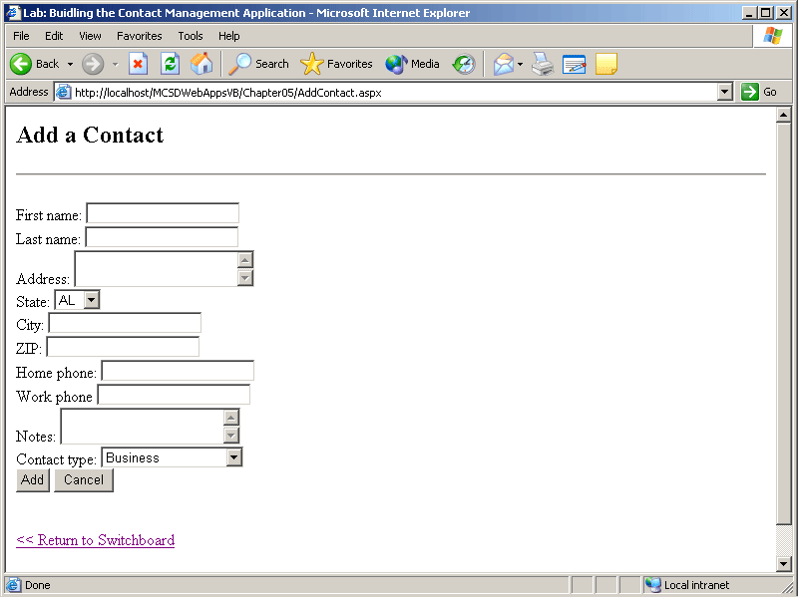
Figure 5-24. The AddContact Web form
To create the AddContact data entry Web form
- Add a new Web form to the project named AddContact.aspx.
- In the Properties window, select the DOCUMENT object and set the pageLayout property to FlowLayout.
- Add controls to the Web form with the property settings shown in the following table:
Control | Property | Setting
TextBox | ID | txtFirstName
TextBox | ID | txtLastName
TextBox | ID | txtAddress
 | TextMode | MultiLine
TextBox | ID | txtCity
DropDownList | ID | drpStates
 | DataSource | arrState
TextBox | ID | txtZIP
TextBox | ID | txtHomePhone
TextBox | ID | txtWorkPhone
TextBox | ID | txtNotes
DropDownList | ID | drpContactTypes
 | DataSource | dsContactTypes
 | DataTextField | ContactType
 | DataValueField | ContactTypeID
Button | ID | butAdd
 | Text | Add
Button | ID | butCancel
 | Text | Cancel
Literal | ID | litStatus
Hyperlink | Text | Return to SwitchBoard
 | NavigateUrl | SwitchBoard.aspx
- Type text to identify the fields directly on the Web form. Use carriage returns to start new lines.
- Double-click the Web form to display the Code window, and then add the following Imports or using statement to the top of the module:
Visual Basic .NET
Imports System.Data.SqlClient
Visual C#
using System.Data.SqlClient;
- The AddContact Web form uses the database components created in Exercise 2 in the SwitchBoard Web form. To use these components in this Web form, declare class-level variables, and then retrieve the references to the components from the state variables where they are stored. The following code demonstrates how to do this:
Visual Basic .NET
Dim adptContacts As SqlDataAdapter
Dim dsContacts As dsContacts
' These variables are public for data binding.
Public dsContactTypes As dsContactTypes
Public arrState As String() = {"AL", "AK", "AR", "AZ", _
"CA", "CO", "CT", "DE", "FL", "GA", "HI", "ID", "IL", _
"IN", "IA", "KS", "KY", "LA", "MA", "ME", "MD", "MI", _
"MN", "MO", "MS", "MT", "NC", "ND", "NE", "NH", "NJ", _
"NM", "NV", "NY", "OH", "OK", "OR", "PA", "RI", "SC", _
"SD", "TN", "TX", "UT", "VA", "VT", "WA", "WI", "WY"}

Private Sub Page_Load(ByVal sender As System.Object, _
ByVal e As System.EventArgs) Handles MyBase.Load
' Get the Cached variables.
adptContacts = Cache("adptContacts")
dsContacts = Cache("dsContacts")
dsContactTypes = Cache("dsContactTypes")
If Not IsPostBack Then
' Bind to data -- populates the drpContactTypes and drpState lists.
drpContactTypes.DataBind()
drpStates.DataBind()
End If
End Sub
Visual C#
SqlDataAdapter adptContacts;
MCSDWebAppsCS.Chapter05.dsContacts dsContacts;
// These variables are public for data binding.
public MCSDWebAppsCS.Chapter05.dsContactTypes dsContactTypes;
public string[] arrState = {"AL", "AK", "AR", "AZ",
"CA", "CO", "CT", "DE", "FL", "GA", "HI", "ID", "IL",
"IN", "IA", "KS", "KY", "LA", "MA", "ME", "MD", "MI",
"MN", "MO", "MS", "MT", "NC", "ND", "NE", "NH", "NJ",
"NM", "NV", "NY", "OH", "OK", "OR", "PA", "RI", "SC",
"SD", "TN", "TX", "UT", "VA", "VT", "WA", "WI", "WY"};

private void Page_Load(object sender, System.EventArgs e)
{
// Get the Cached variables.
adptContacts = (SqlDataAdapter) Cache["adptContacts"];
dsContacts = (dsContacts) Cache["dsContacts"];
dsContactTypes = (dsContactTypes) Cache["dsContactTypes"];
if (!IsPostBack)
{
// Bind to data -- populates drpContactTypes and drpState lists.
drpContactTypes.DataBind();
drpStates.DataBind();
}
}
- Each contact in the Contacts table is identified by a ContactID. This is the primary key for the table, so it must be unique for each contact. Therefore, before you can add a contact to the Contacts data set, you must obtain a new, unique ContactID from the database. Add the following helper function to the Web form class to get this unique ID before adding the contact:
Visual Basic .NET
' Helper function to get a new, valid row ID.
Function GetNewID(ByVal dt As DataTable) As Integer
' Get a new row number.
Dim NextID As Integer = dt.Rows.Count + 1
' If it isn't found in the table, return it.
If IsNothing(dt.Rows.Find(NextID)) Then Return NextID
' Otherwise, check for free IDs between 1 and the row count.
For NextID = 1 To dt.Rows.Count
' Check if this ID already exists.
If IsNothing(dt.Rows.Find(NextID)) Then
Return NextID
End If
Next
' Failed, return zero.
Return 0
End Function
Visual C#
// Helper function to get a new, valid row ID.
int GetNewID(DataTable dt)
{
// Get a new row number.
int NextID = dt.Rows.Count + 1;
// If it isn't found in the table, return it.
if (dt.Rows.Find(NextID) == null) return NextID;
// Otherwise, check for free IDs between 1 and the row count.
for(NextID = 1; NextID <= dt.Rows.Count; NextID++)
{
// Check if this ID already exists.
if (dt.Rows.Find(NextID) == null) return NextID;
}
// Failed, return zero.
return 0;
}
- Add the following butAdd_Click event procedure to add the new contact information to the database:
Visual Basic .NET
Private Sub butAdd_Click(ByVal sender As System.Object, _
ByVal e As System.EventArgs) Handles butAdd.Click
' Create a new row for the data set.
Dim rowNew As dsContacts.ContactsRow
rowNew = dsContacts.Contacts.NewContactsRow()
' Add data to the row.
rowNew.ContactID = GetNewID(dsContacts.Tables("Contacts"))
rowNew.FirstName = txtFirstName.Text
rowNew.LastName = txtLastName.Text
rowNew.Address = txtAddress.Text
rowNew.City = txtCity.Text
rowNew.StateOrProvince = drpStates.SelectedItem.Text
rowNew.PostalCode = txtZip.Text
rowNew.HomePhone = txtHomePhone.Text
rowNew.WorkPhone = txtWorkPhone.Text
rowNew.Notes = txtNotes.Text
rowNew.ContactTypeID = drpContactTypes.SelectedItem.Value
' Add the row to the data set.
dsContacts.Contacts.AddContactsRow(rowNew)
'dsContacts.Contacts.Rows(0).Table.Columns(0).ToString()
Try
' Modify the database.
adptContacts.Update(dsContacts)
' Show success.
litStatus.Text = rowNew.FirstName & " " & rowNew.LastName & _
" added successfully.<br>"
' Clear fields.
ClearTextBoxes()
' Occurs if ContactID is not unique.
Catch ex As Exception
litStatus.Text = "The following database error occurred:<br>" & _
ex.Message & "<br>" & _
"Correct the error and click Add to add the contact " & _
"or click Cancel to abort.<br>"
End Try
End Sub
Visual C#
private void butAdd_Click(object sender, System.EventArgs e)
{
// Create a new row for the data set.
dsContacts.ContactsRow rowNew;
rowNew = dsContacts.Contacts.NewContactsRow();
// Add data to the row.
rowNew.ContactID = GetNewID(dsContacts.Tables["Contacts"]);
rowNew.FirstName = txtFirstName.Text;
rowNew.LastName = txtLastName.Text;
rowNew.Address = txtAddress.Text;
rowNew.City = txtCity.Text;
rowNew.StateOrProvince = drpStates.SelectedItem.Text;
rowNew.PostalCode = txtZip.Text;
rowNew.HomePhone = txtHomePhone.Text;
rowNew.WorkPhone = txtWorkPhone.Text;
rowNew.Notes = txtNotes.Text;
rowNew.ContactTypeID =
Convert.ToInt16(drpContactTypes.SelectedItem.Value);
// Add the row to the data set.
dsContacts.Contacts.AddContactsRow(rowNew);
try
{
// Modify the database.
adptContacts.Update(dsContacts);
// Show success.
litStatus.Text = rowNew.FirstName + " " + rowNew.LastName +
" added successfully.<br>";
// Redisplay page to clear fields.
ClearTextBoxes();
}
// General data exception, so report it.
catch(Exception)
{
litStatus.Text = "The following database error occurred:<br>" +
ex.Message + "<br>" +
"Correct the error and click Add to add the contact " +
"or click Cancel to abort.<br>";
}
}
- Add the butCancel_Click event procedure to allow the user to cancel the operation and clear the text boxes on the form:
Visual Basic .NET
Private Sub butCancel_Click(ByVal sender As System.Object, _
ByVal e As System.EventArgs) Handles butCancel.C lick
' Clear text fields on this page.
ClearTextBoxes()
End Sub

' Helper function to clear all the text boxes on this page.
Sub ClearTextBoxes()
Dim ctrl As Control
For Each ctrl In Page.Controls
If TypeOf ctrl Is HtmlForm Then
Dim subctrl As Control
For Each subctrl In ctrl.Controls
If TypeOf subctrl Is System.Web.UI.WebControls.TextBox _
Then CType(subctrl, TextBox).Text = ""
Next
End If
Next
End Sub
Visual C#
private void butCancel_Click(object sender, System.EventArgs e)
{
ClearTextBoxes();
}

void ClearTextBoxes()
{
foreach(object ctrl in Page.Controls)
{
if (ctrl is System.Web.UI.HtmlControls.HtmlForm)
{
System.Web.UI.HtmlControls.HtmlForm form =
(System.Web.UI.HtmlControls.HtmlForm)ctrl;
foreach(object subctrl in form.Controls)
{
if (subctrl is System.Web.UI.WebControls.TextBox)
{
TextBox textctrl = (TextBox)subctrl;
textctrl.Text = "";
}
}
}
}
}
Exercise 4: Create the Calls Form
The Calls Web form lets users enter and view telephone calls from a contact. It uses a DataList control to view the telephone calls for a contact selected in a DropDownList control and contains the controls that add a call in a Panel control so that they can be hidden and displayed when the user clicks Add.
When completed, the Calls Web form appears as shown in Figure 5-25.
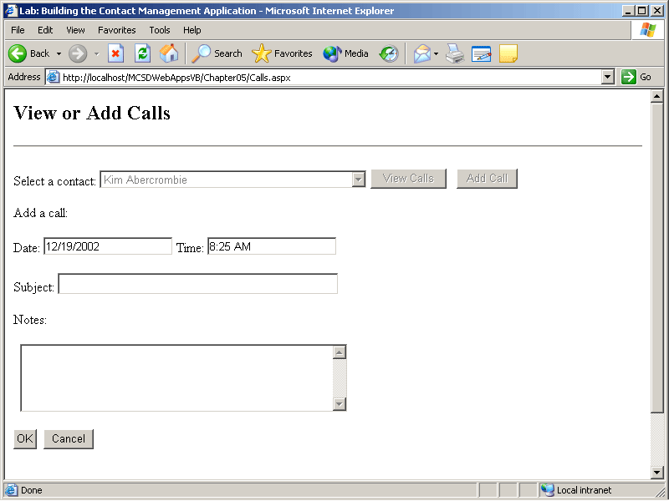
Figure 5-25. The Calls form
To create the Calls Web form
- Add a new Web form to the project named Calls.aspx.
- Add controls to the Web form with the property settings shown in the following table. Place the controls shown after the Panel control inside the panel so that you can easily control their display at run time.
Control | Property | Setting
DropDownList | ID | drpContacts
Button | ID | butView
 | Text | View Call
Button | ID | butAddCall
 | Text | Add Call
Panel | ID | pnlAdd
TextBox | ID | txtDate
TextBox | ID | txtTime
TextBox | ID | txtSubject
TextBox | ID | txtNotes
 | TextMode | Multiline
Button | ID | butOKAdd
 | Text | OK
Button | ID | butCancelAdd
 | Text | Cancel
Literal | ID | litError
- Open the Data tab in the Toolbox, and drag a DataSet onto the Web form. Visual Studio displays the Add Dataset dialog box with the Typed Dataset option selected.
- In the Name drop-down list, select the typed data set named ContactManagement.dsCalls, and click OK. Visual Studio adds the data set to the Web form.
- From the Web Forms tab in the Toolbox, add a DataList control to the Web form below the panel. Set its properties and edit its templates as shown in the following table:
Control | Property | Setting
DataList | ID | dlstCalls
 | DataSource | dsCalls.Tables(“Calls”).DefaultView (VB)  dsCalls.Tables[“Calls”].DefaultView (C#)
DataList Header Template
Regular text | None | Calls
HTML rule | None | <HR>
DataList Footer Template
HTML rule | None | <HR>
DataList Item Template
Label | ID | lblDate
 | (DataBindings) | Using the DataBindings dialog box, select the Text property, and enter this custom binding expression: DataBinder.Eval(Container, "DataItem.CallDate", "{0:d}").
Label | ID | lblTime
 | (DataBindings) | Using the DataBindings dialog box, select the Text property and enter this custom binding expression: DataBinder.Eval(Container, "DataItem.CallTime", "{0:t}").
Regular text | None | Subject:
Label | ID | lblSubject
 | (DataBindings) | Using the DataBindings dialog box, select the Text property and enter the following custom binding expression: DataBinder.Eval(Container, “DataItem.Subject”).
Regular text | None | Notes:
Label | ID | lblNotes
 | (DataBindings) | Using the DataBindings dialog box, select the Text property and enter the following custom binding expression: DataBinder.Eval(Container, “DataItem.Notes”).
Separator Template
HTML rule | None | <HR>
- Copy the Hyperlink control from the bottom of the AddContact form to the bottom of the Calls form. To copy the control, select the control and press Ctrl+C. To paste the copy onto the Calls form, click the form in Design mode and press Ctrl+V.
- Double-click the Calls Web form to display the Code window, and add the following Imports or using statements to the top of the module:
Visual Basic .NET
Imports System.Data.SqlClient
Visual C#
using System.Data.SqlClient;
- The Calls Web form uses the data components from the cache, so you need to retrieve references to those components from the Cache variables created in Exercise 2. The following declarations and Page_Load event procedure retrieve references to the data components and make them available to the form code:
Visual Basic .NET
Dim adptCalls As SqlDataAdapter
Dim dsCalls As dsCalls
Dim dsContacts As dsContacts

Private Sub Page_Load(ByVal sender As System.Object, _
ByVal e As System.EventArgs) Handles MyBase.Load
' Get cached variables.
adptCalls = Cache("adptCalls")
dsCalls = Cache("dsCalls")
dsContacts = Cache("dsContacts")
' Run the first time page is displayed.
If Not IsPostBack Then
' For each row in the table...
Dim rowNext As dsContacts.ContactsRow
For Each rowNext In dsContacts.Contacts
' Create a new list item.
Dim lstNew As New ListItem()
lstNew.Text = rowNext.FirstName & " " & rowNext.LastName
lstNew.Value = rowNext.ContactID
' Add the list item to the drop-down list.
drpContacts.Items.Add(lstNew)
Next
' Select the first item in the list.
drpContacts.SelectedIndex = 0
End If
End Sub
Visual C#
SqlDataAdapter adptCalls;
dsContacts dsContacts;
public dsCalls dsCalls;

private void Page_Load(object sender, System.EventArgs e)
{
// Get cached variables.
adptCalls = (SqlDataAdapter) Cache["adptCalls"];
dsCalls = (dsCalls)Cache["dsCalls"];
dsContacts = (dsContacts)Cache["dsContacts"];
// Run the first time page is displayed.
if (!IsPostBack)
{
// For each row in the table...
foreach (dsContacts.ContactsRow rowNext in dsContacts.Contacts)
{
// Create a new list item.
ListItem lstNew = new ListItem();
lstNew.Text = rowNext.FirstName + " " + rowNext.LastName;
lstNew.Value = rowNext.ContactID.ToString();
// Add the list item to the drop-down list.
drpContacts.Items.Add(lstNew);
}
// Select the first item in the list.
drpContacts.SelectedIndex = 0;
}
- Add the following code for the View Call and Add Call button Click event procedures:
Visual Basic .NET
Private Sub butView_Click(ByVal sender As System.Object, _
ByVal e As System.EventArgs) Handles butView.Click
' Set the filter for the view to display.
dsCalls.Tables("Calls").DefaultView.RowFilter = "ContactID=" + _
drpContacts.SelectedItem.Value.ToString()
' Bind to the DataList control
dlstCalls.DataBind()
End Sub

Private Sub butAddCall_Click(ByVal sender As System.Object, _
ByVal e As System.EventArgs) Handles butAddCall.Click
' Set the initial date and time values.
txtDate.Text = Now.ToShortDateString()
txtTime.Text = Now.ToShortTimeString()
' Make add call panel visible
pnlAdd.Visible = True
' Disable buttons/DropDown list.
butView.Enabled = False
butAddCall.Enabled = False
drpContacts.Enabled = False
End
Sub
Visual C#
private void butView_Click(object sender, System.EventArgs e)
{
// Set the filter for the view to display.
dsCalls.Tables["Calls"].DefaultView.RowFilter = "ContactID=" +
drpContacts.SelectedItem.Value.ToString();
// Bind to the DataList control
dlstCalls.DataBind();
}

private void butAddCall_Click(object sender, System.EventArgs e)
{
// Set the initial date and time values.
txtDate.Text = System.DateTime.Now.ToShortDateString();
txtTime.Text = System.DateTime.Now.ToShortTimeString();
// Make add call panel visible
pnlAdd.Visible = true;
// Disable buttons/DropDown list.
butView.Enabled = false;
butAddCall.Enabled = false;
drpContacts.Enabled = false;
}
- Add the following helper function to get a new CallID value. Because CallID is the primary key in the Calls table, you need a value that is unique within the database. This code is the same as used in the AddContact Web form and can, alternatively, be placed in a class module of helper functions and used from there.
Visual Basic .NET
' Helper function to get a new, valid row ID.
Function GetNewID(ByVal dt As DataTable) As Integer
' Get a new row number.
Dim NextID As Integer = dt.Rows.Count + 1
' If it isn't found in the table, return it.
If IsNothing(dt.Rows.Find(NextID)) Then Return NextID
' Otherwis, check for free IDs between 1 and the row count.
For NextID = 1 To dt.Rows.Count
' Check if this ID already exists.
If IsNothing(dt.Rows.Find(NextID)) Then
Return NextID
End If
Next
' Failed, return zero.
Return 0
End Function
Visual C#
// Helper function to get a new, valid row ID.
int GetNewID(DataTable dt)
{
// Get a new row number.
int NextID = dt.Rows.Count + 1;
// If it isn't found in the table, return it.
if (dt.Rows.Find(NextID) == null) return NextID;
// Otherwis, check for free IDs between 1 and the row count.
for(NextID = 1; NextID <= dt.Rows.Count; NextID++)
{
// Check if this ID already exists.
if (dt.Rows.Find(NextID) == null) return NextID;
}
// Failed, return zero.
return 0;
}
- Add the following code to the OK and Cancel button event procedures. These event procedures are very similar to the ones used to add or cancel the adding of records in the Contacts table in Exercise 3.
Visual Basic .NET
Private Sub butOKAdd_Click(ByVal sender As System.Object, _
ByVal e As System.EventArgs) Handles butOKAdd.Click
Dim rowNew As dsCalls.CallsRow
rowNew = dsCalls.Calls.NewCallsRow
rowNew.ContactID = drpContacts.SelectedItem.Value
rowNew.CallID = GetNewID(dsCalls.Tables("Calls"))
rowNew.CallDate = txtDate.Text
rowNew.CallTime = txtDate.Text & " " + txtTime.Text
rowNew.Subject = txtSubject.Text
rowNew.Notes = txtNotes.Text
' Add row to calls data set.
dsCalls.Calls.AddCallsRow(rowNew)
Try
adptCalls.Update(dsCalls)
' Hide the add call panel.
pnlAdd.Visible = False
' Clear the fields.
txtSubject.Text = ""
txtNotes.Text = ""
' Enable the other controls.
butView.Enabled = True
butAddCall.Enabled = True
drpContacts.Enabled = True
Catch ex As Exception
' Display error.
litError.Text = "The following error occurred while adding " + _
"the call:<br>" + ex.Message & "<br>" + _
"Correct the error and try again, "+_
"or click Cancel to abort.<br>"
End Try
End Sub

Private Sub butCancelAdd_Click(ByVal sender As System.Object, _
ByVal e As System.EventArgs) Handles butCancelAdd.Click
' Hide the add call panel.
pnlAdd.Visible = False
' Clear the fields.
txtSubject.Text = ""
txtNotes.Text = ""
' Enable the other controls.
butAddCall.Enabled = True
drpContacts.Enabled = True
End Sub
Visual C#
private void butOKAdd_Click(object sender, System.EventArgs e)
{
MCSDWebAppsCS.Chapter05.dsCalls.CallsRow rowNew;
rowNew = dsCalls.Calls.NewCallsRow();
rowNew.ContactID = Convert.ToInt16(drpContacts.SelectedItem.Value);
rowNew.CallID = GetNewID(dsCalls.Calls);
rowNew.CallDate = Convert.ToDateTime(txtDate.Text);
rowNew.CallTime = Convert.ToDateTime(txtTime.Text);
rowNew.Subject = txtSubject.Text;
rowNew.Notes = txtNotes.Text;
// Add row to calls data set.
dsCalls.Calls.AddCallsRow(rowNew);
try
{
adptCalls.Update(dsCalls);
// Hide the add call panel.
pnlAdd.Visible = false;
// Clear the fields.
txtSubject.Text = "";
txtNotes.Text = "";
// Enable the other controls.
butView.Enabled = true;
butAddCall.Enabled = true;
drpContacts.Enabled = true;
}
catch (Exception ex)
{
// Display error.
litError.Text = "The following error occurred while adding " +
"the call:<br>" +
ex.Message + "<br>" +
"Correct the error and try again, or click Cancel to " +
"abort.<br>";
}
}

private void butCancelAdd_Click(object sender, System.EventArgs e)
{
// Hide the add call panel.
pnlAdd.Visible = false;
// Clear the fields.
txtSubject.Text = "";
txtNotes.Text = "";
// Enable the other controls.
butAddCall.Enabled = true;
drpContacts.Enabled = true;
}
}
Exercise 5: Create the DeleteContact and ContactTypes Forms
So far, this lab has shown you how to create Web forms in a step-by-step fashion. Now it’s time to strike out on your own! Create the DeleteContact and ContactTypes Web forms by yourself.
These Web forms should perform the following tasks:
- Use the data components from the cache.
- Perform operations on the database. The DeleteContact form should allow users to delete contacts from the database. The ContactTypes form should allow users to view and add new contact types.
- Use data set transactions, as demonstrated by the AddContact and Calls forms.
- Provide navigation back to the SwitchBoard form.
When you have finished, compare your results to the Contact Management sample included on the companion CD. Good luck!
Review
The following questions are intended to reinforce key information presented in this chapter. If you are unable to answer a question, review the appropriate lesson and then try the question again. Answers to the questions can be found in the appendix.
- What steps would you follow and what objects would you use to quickly find the number of records in a database table?
- How do typed data sets differ from untyped data sets, and what are the advantages of typed data sets?
- How do you call a stored procedure?
- Explain the difference between handling transactions at the data set level and at the database level.

